**The Battle of Hamburger Hill**

**10-20 May 1969**

**A Vietnam War Virtual Staff Ride**

**Instructions and Readings**

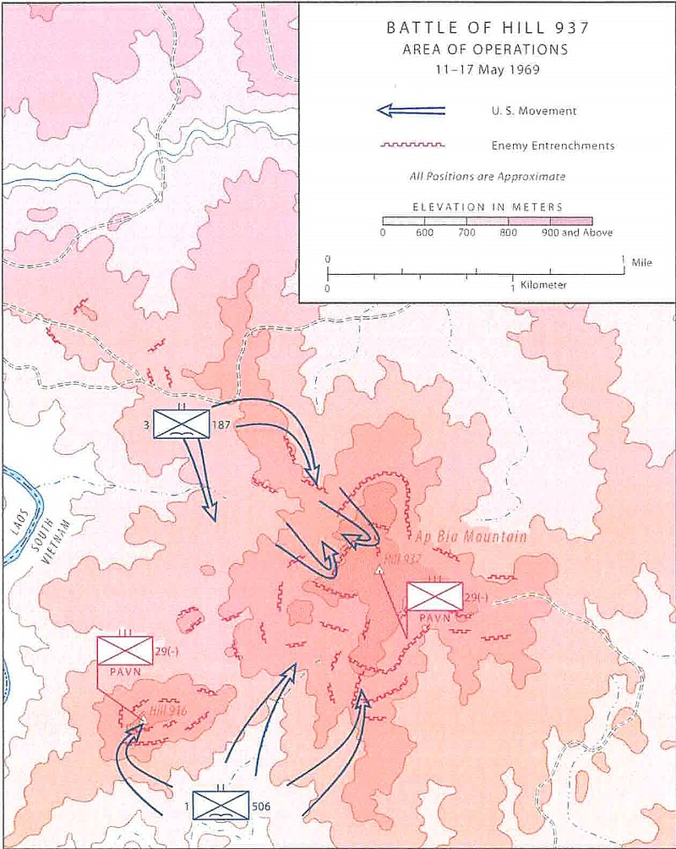

**Combat Studies Institute**

**The Army University Press**

**Fort Leavenworth, Kansas 66027-6900**

**June 2020**

**The Battle of Hamburger Hill**

**STUDY INSTRUCTIONS FOR THE STAFF RIDE**

**READINGS AND MAPS:**

1. **Background**
2. **A Shau Valley**
3. **Origins of Operation Apache Snow**
4. **Battle of Dong Ap Bia* (10 -20 May 1969)**
5. **Aftermath**

**Annex A: 3-187th Airborne Infantry Battalion/Company/Platoon (The Rakkasans)**

**Appendix B: Tactical Air and Artillery Fire Support**

**Appendix C: 4-77th Artillery (Aerial Rocket Artillery).**

**Appendix D: The 29th Regiment (North Vietnamese Army).**

*Dong Ap Bia is the official name of the battle. It is the local name for the hill meaning *“The Crouching Beast.”* Soldiers, and later the press, called it *“Hamburger Hill”* several days into the fight.

**Study Instructions**

**for the Battle of Hamburger Hill**

**Virtual Staff Ride**

1. **Overview:**
   1. This Army University Press-Combat Studies Institute virtual staff ride examines the actions of 3d Brigade, 101st Airborne Division at the Battle of Dong Ap Bia (also known as the Battle of Hamburger Hill). Most of the tactical discussion focuses on the efforts of Lieutenant Colonel Weldon Honeycutt’s 3-187th Infantry (the Rakkasans) to defeat the 29th North Vietnamese Infantry Regiment and seize Hill 937 (Hamburger Hill).
   2. The material in this packet is designed to assist in preparing for the virtual staff ride. The readings provide context for the operation and give the participants the details of the battle that will be covered during the virtual staff ride. It is highly recommended that participants read all of the material and take notes for use during the staff ride.
   3. The staff ride is not a lecture; it is a facilitated discussion. The better prepared the participants are, the better the staff ride will go.
2. **Divide the staff ride participants into 7 groups:**

* **Group 1: The North Vietnamese Army (NVA) 29th Infantry Regiment**. This group will have significant participation during the entire staff ride and should attempt to analyze the action from the perspective of the NVA forces.
  + This is a challenging assignment. At this time, there are no NVA first person accounts of the fight.
  + The readings are from the US Army perspective. The NVA group will need to make their own analysis of the readings and reverse-engineer the story to discuss what they perceive to be the NVA plan and the execution of that plan.
* **Group 2: Lieutenant Colonel Weldon Honeycutt, commander 3-187th Infantry.** This group should analyze the decisions and actions of LTC Honeycutt and the battalion staff.
* **Group 3: Alpha Company/3-187th Infantry.** This group should analyze the decisions and actions of the key leaders and personnel of the company.
  + Captain Gerald Harkins
  + 1st Plt: Daniel Bresnahan
  + 2d Plt: Lt. Frank McGreevy
  + 3d Plt: Gorde Atcheson
* **Group 4: Bravo Company/3-187th Infantry and A/2-506th Infantry.** This group should analyze the decisions and actions of the key leaders and personnel of Bravo/3-187 and A/2-506th. Bravo Company is the battalion main effort for the first 6 days of the battle and then becomes the reserve. A/2-506th Infantry is attached to the 3-187th IN toward the end of the battle.
  + **Bravo/3-187:** Captain Charles Littnan. then Captain Chappel
    - 1st Plt: Frank Boccia
    - 2d Plt: Marshall Eward
    - 3d Plt: SFC Louis Garza then Lt Lou Charles
    - 4th Plt: Chuck Denholm
  + **A/2-506th:** Captain Bill Womble
    - 1st Plt: Len Maher
    - 2d Plt: ____
    - 3d Plt: ____
* **Group 5: Charlie Company/3-187th Infantry.** This group should analyze the decisions and actions of the key leaders and personnel of the company.
  + Captain Dean Johnson
  + 1st Plt: Joel Trautman
  + 2d Plt: Donald Sullivan
  + 3d Plt: James Goff
* **Group 6: Delta Company/3-187th Infantry.** This group should analyze the decisions and actions of the key leaders and personnel of the company.
  + Cpt Luther Sanders
  + 1st Plt: Jerry Walden
  + 2d Plt: Thomas Lipscomb
  + 3d Plt: Mattioli
* **Group 7: Colonel Joseph Conmy, commander 3d Brigade, 101st Airborne Division.** This group should analyze the decisions and actions of the brigade. This group is also responsible for overview the actions of the other units in the brigade. This includes Tactical Air Support, Fire Support, and Army Aviation. **(Note – Groups 7 could be divided into multiple groups)**
  + 3d Brigade, 101st ABN DIV
  + 1-506th Infantry: (Could be a separate group)
  + 2-501st Infantry (very limited participation in the staff ride)
  + 3d Battalion, 1st ARVN Regiment (very limited participation tin the staff ride)
  + 2d Battalion, 3d ARVN Regiment (very limited participation in the last stand)
  + Tactical Air Support
  + Fire Support These could be combined to form a group.
  + Army Aviation

**The Battle of Hamburger Hill**

**10-20 May 1969**

Background: Excerpt from CMH PUB 76 -6, *The U.S. Army Campaigns of the Vietnam War – Transition Nov 1968-Dec 1969*, 7, 29-31.

By 1969, the government of South Vietnam, backed by U.S. advisers, had been fighting Communist Viet Cong insurgents and their patrons in neighboring North Vietnam for fifteen years. It was a desperate struggle that pitted neighbor against neighbor and exacted a mounting toll in the form of casualties, refugees, and socioeconomic dislocation. In 1965, the United States had added its own ground combat troops to the struggle, thwarting the very real prospect of a Communist victory. Since that low point, it was believed that the allies were gradually gaining ground in an escalating conflict.

|  |  |
| --- | --- |
| **TIME LINE / TROOP STRENGTH** | |
| 1961: Green Berets (3205)  1964: Gulf Tonkin Resolution (23,300)  1965 (184,300):   * Gen. Westmoreland **“War of Attrition”** * Battle of Ia Drang Valley (We Were Soldiers) * Draft increased to 35,000 each month   1966 (385,300) | 1967: Major protests in US (485,600):  1968 (536,100):   * Gen. Abrams continues **“War of Attrition”** * TET Offense * Nixon wins election **“Peace Initiative”**   **1969: HAMBURGER HILL (475,200)**  1970: Vietnamization (335,790)  1971- 1972: (156,800 down to 24,200)  1973: Paris Peace Accords (50) |
| Stewart, Richard, *AMERICAN MILITARY HISTORY, VOLUME II, THE UNITED STATES ARMY IN A GLOBAL ERA, 1917-2003,* Washington, D.C: Center of Military History, 2005, 333 | |

In late January 1968, the Communist leadership in North Vietnam had launched a major offensive in a bid to change the situation in its favor. The widespread attacks, which began during the Tet New Year holidays and continued on and off through September, failed miserably. The population of South Vietnam refused to rise up in support, and the Communists suffered enormous casualties. As the enemy aggression abated, the commander of U.S. Military Assistance Command, Vietnam (MACV), General Creighton W. Abrams, believed the allies were poised to make significant gains. But time was not on his side. Although the allies had defeated the enemy militarily, the shock that the Communists had been able to launch such a massive strike after years of American involvement had undermined support for the war back in the United States. With peace talks under way in Paris, Abrams raced against the clock to give South Vietnam the best chance for survival before the inevitable withdrawal of U.S. troops.

Driving the intensity of U.S. activity across South Vietnam in early 1969 was Abrams’ belief that the enemy would launch a major offensive around the time of the Tet holidays, just as he had done in 1968. Outgoing President Johnson had made the enemy’s job easier in November 1968 when he had unilaterally suspended the bombing of North Vietnam in the hope of coaxing the Communists into serious negotiations. The Communists had taken advantage of the suspension by improving infiltration routes and by building a petroleum pipeline in the Demilitarized Zone. Troops and materiel had poured into South Vietnam during the following months, reinforcing Abrams’ suspicions about a new Tet offensive and prompting him to launch spoiling actions throughout the winter. During the first forty days of 1969, aggressive allied actions captured large quantities of Communist weaponry.

Allied preemptive measures could not stop the enemy, but they greatly limited the impact of his offensive when it finally began in the early morning hours of 23 February. During the action that followed, the enemy struck over 125 major targets and 400 lesser ones. In many cases he eschewed ground assaults for bombardments delivered by mortars, artillery, and rockets. Two enemy divisions did attack logistical installations outside of Saigon, but the allies rebuffed these. Operations against Hue and other coastal cities in the northern part of the country proved stillborn, while in the Central Highlands, the Communists made only one significant thrust. In late February, the North Vietnamese began bombarding the Ben Het Special Forces camp, thirty-five kilometers northwest of Kontum City. They followed up in early March with several assaults involving the *66th PAVN Regiment* and a contingent of Russian-made PT–76 light tanks. Backed by elements of the 4th Infantry Division and U.S. aircraft, the camp weathered the challenge, although a desultory siege would continue for several more months. During the action that followed, the enemy struck over 125 major targets and 400 lesser ones. In many cases he eschewed ground assaults for bombardments delivered by mortars, artillery, and rockets. Two enemy divisions did attack logistical installations outside of Saigon, but the allies rebuffed these.

Taken as a whole, the 1969 (2d) Tet offensive was a bust. Communist losses soared—from 27,400 dead in the last quarter of 1968 to nearly 45,000 in the first quarter of 1969—with very little to show for the sacrifice. General Abrams believed his strategy of launching spoiling attacks against enemy bases and supply routes had taken the wind out of the Communists’ sails, thereby limiting the impact of the offensive. In the case of III Corps, the enemy’s major target, Abrams particularly credited the 1st Cavalry Division and the 11th Armored Cavalry for blunting the blow. Thanks to them, he said, the enemy ***“had to wrestle with us from the Cambodian border all the way down [toward Saigon]. They’ve [the 1st Cavalry Division] ridden him, taken his stuff away from him, and he’s just had a hell of a time.”***

In fact, spoiling actions had been so successful that Abrams made them a centerpiece of post-Tet operations. Many of the largest of these missions during the first months of 1969 took place in I Corps, which was particularly vulnerable to infiltration due to its proximity to North Vietnam and Laos. The greatest threat came from Laos, which meant that U.S. forces had to move westward into the heavily forested Anamite Mountains if they were to effectively interfere with the enemy’s ability to amass the supplies he needed to mount large-scale attacks. In late January, elements of the 3d Marine Division had begun operating along the Laotian border in Quang Tri and Thua Thien Provinces. In mid-March, the 1st Brigade, 5th Division, reinforced the effort by forming a heavily armored group called Task Force Remagen that advanced along Highway 9 from Ca Lu to the Khe Sanh plateau in western Quang Tri Province. It then turned south to interdict the border and screen the northern flank of the marines searching for enemy units and bases in the valleys to the southeast. Task Force Remagen roamed the area until the end of April, encountering light resistance.

Meanwhile, reports of an enemy buildup in the A Shau Valley, one of the main avenues into South Vietnam in western Thua Thien Province, caused Maj. Gen. Melvin Zais’ 101st Airborne Division to join the hunt. The allies had swept the rugged defile several times in previous years, but it was too remote to permanently control, and the enemy always returned from across the Laotian border after the Americans had left. Nor was it easy for the Americans to return. Each foray required an extensive engineering effort to build or restore the artillery firebases, landing zones, and roads needed to keep the combat troops supplied and supported in the heavily forested interior. Zais’ paratroopers uncovered a number of logistical facilities in a series of operations conducted in February, March, and April, but rarely did the enemy choose to stand and fight. This changed on 10 May when the 3d Brigade, 101st Airborne Division launched Operation Apache Snow into the valley where intelligence again indicated a significant enemy presence.

|  |
| --- |
| **The North Vietnamese Army Normally Defended By Evading**  The North Vietnamese Army and the Viet Cong normally defended by evading. Only occasionally would they defend a position as a feint or deception, trying to draw allied forces into a trap or to divert them from a larger unit nearby. Enemy tacticians recognized that the allied forces were superior in firepower and mobility. To overcome this superiority, the enemy attempted to mass, attack, and withdraw before allied forces could react. Each of the enemy's operations was planned in minute detail and often rehearsed… The survival of the enemy forces on the battlefield depended on their ability to disengage from or avoid contact with allied forces. They considered the withdrawal phase of the operation as important as any other combat action. When necessary, they would counterattack in an attempt to disengage. If routes leading away from the battlefield were blocked, the enemy troops would try to attack a weak spot in the allied position and escape through the breach. Delaying forces would ambush and harass pursuers. If an orderly withdrawal was not possible, small unit commanders would disperse their troops in the hope of rendezvousing later at a predesignated point. |
| Hay, John (LTG). Tactical and Material Innovations (CMH Pub 90-21-1). Washington, D.C: Center of Military History, 1974, 5 |

**A Shua Valley:** Excerpt from *The Brigade: A History, Its Organization and Employment in the US Army* by John McGrath. Combat Studies Institute Press, Fort Leavenworth, Kansas, 2004, 69-71.

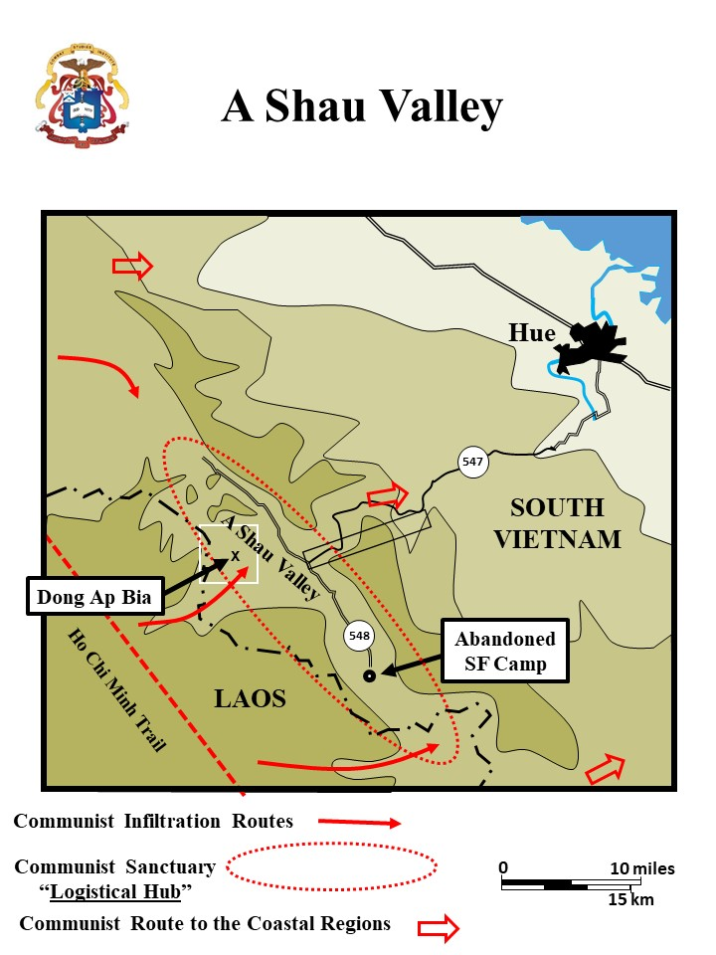

The A Shau Valley was located on the Laotian border 25miles west of Hue. It had been a North Vietnamese-controlled sanctuary since a Special Forces camp had been driven out of the valley in 1966. Since then, the valley and its adjoining jungle-covered ridgelines had become a major Communist base area and supply route into the coastal regions of Thua Thien province, Hue, and Quang Tri province to the north. The enemy forces that attacked Hue city during the Tet Offensive in 1968 had assembled in the A Shau Valley and infiltrated out of there. The valley’s location next to the safe haven of Laos and the Ho Chi Minh Trail made it of great importance to the North Vietnamese. In 1968, the 1st Cavalry Division (Airmobile) had conducted operations in the valley, but did not establish a permanent presence there. After the air cavalry’s departure, the Communists restored their infrastructure, which included a main supply route running down the middle of the valley on an improved road (Route 548). Jungle covered mountains surrounded the valley itself. One of these, was Dong Ap Bia, ***“The Crouching Beast”*** and later known as ***“Hamburger Hill.”***

|  |
| --- |
| **Communist Logistical Hubs**  The Communists depended on logistical hubs to sustain their forces in Vietnam.  Logistical installations were usually located in areas well shielded by mountains, swamps, or heavily canopied jungle. The A Shua valley was one of these locations and supported operations against the highly population coastal region around Hue. These installations contained everything the troops needed to wage war: headquarters, training facilities, ammunition and supply depots, repair shops, hospitals, barracks, and even rest areas. Communist commanders drew upon them well ahead of attacks to stockpile food, ammunition, and whatever other supplies they would need in small caches near their targets. They called the process ***“preparing the battlefield.”*** |
| Villard, Erik. *STAYING THE COURSE October 1967 to September 1968.* Washington, DC: Center for Military History, 2017, 36 |

**Origins of Operation Apache Snow:** *XXIV Corps Historical Summary of the Battle of AT Dong Ap Bia (Hamburger Hill) 10 – 20 May 1969*. Headquarters XXIV Corps, 1971.

The battle at Dong Ap Bia (Hamburger Hill) occurred during Operation APACHE SNOW, a XXIV Corps directed operation in the Northern A Shau Valley. This operation was initiated on 10 May 1969 with the specific purpose of destroying North Vietnamese Army (NVA) and Viet Cong (VC) forces believed to be grouping in the A Shau Valley, blocking enemy routes of egress into Laos, interdicting enemy lines of communication and locating and destroying known enemy caches. Allied forces participating in the operation consisted of elements of the 101st Airborne Division, 3d Marine Division, and the 1st ARVN Division. Since the battle at Dong Ap Bia, many people, both in and out of the government, have questioned the advisability of having conducted an operation deep in the mountainous jungle region and removed from the populated area of the country by several miles. Many apparently viewed the operation as being counter to US efforts to obtain a negotiated peace through the Paris peace talks, which were already underway, and contrary to the announced intention of the US government to reduce the level of its combat operations in South Vietnam. The explanation is simple. The A Shau Valley has traditionally been used as a major infiltration route into South Vietnam by the NVA/VC. It is through and from the A Shau Valley that the enemy has supported and launched most of his operations in the Northern provinces of South Vietnam, particularly those operations aimed at the population centers of Hue and Da Nang. Enemy forces have habitually infiltrated through Laos and staged in safe sanctuaries just across the Laos/South Vietnam border from the A Shau Valley. Enemy supplies have likewise been infiltrated and stored in major supply **"warehouses"** both in the A Shau and in nearby base areas in Laos. The A Shau Valley provides accessible and reasonably easy routes for the subsequent movement of both men and materiel either south toward Da Nang or east toward Hue. It was from here that the enemy launched and supported his offensive during Tet 1968 when they inflicted such terrible damage on the city of Hue and murdered an untold number of innocent civilians. Intelligence gained during the spring of 1969 provided evidence of increased enemy activity in the A Shau Valley and adjoining areas in Laos. Aerial observers noted intensive building activity on the roads and trails leading in from Laos which were used for the movement of supplies and equipment. Despite heavy aerial interdiction efforts, it appeared certain that the NVA was moving materiel into the area. Intelligence sources also provided strong indications that elements of three NVA regiments were being infiltrated into the base area (Base Area 611) just west of the A Shau Valley.

|  |
| --- |
| **Intelligence Estimate of the Enemy**  The American and South Vietnamese units participating in Apache Snow knew, based on existing intelligence and previous experiences in the A Shau that they were in for a tough fight. Beyond that, however, they had little evidence as to the enemy's actual strength and dispositions. Masters of camouflage, the NVA completely concealed their bases from aerial surveillance. When the NVA moved, they did so at night along trails covered by triple-canopy jungle, again confounding observation from above. They effected their command and control mainly by runner and wire, leaving no electronic signature for the Americans to monitor or trace. Technology, therefore, provided scant assistance to the American battalion commander trying to **"see the enemy"** during Apache Snow. He had to generate his own tactical intelligence. Patrols, captured equipment, installations, documents, and occasionally prisoners provided combat commanders with the raw data from which to draw their assessment of the enemy order of battle and dispositions. Gathering this information took time, though. Moreover, intelligence about the enemy's strength and dispositions did not necessarily illuminate his commander's intent. It took days to ascertain this, and the learning experience proved decidedly unpleasant for the Americans. |
| Scalard, Douglas (LTC). “The Battle of Hamburger Hill: Battle Command in Difficult Terrain Against a Determined Enemy.” *Studies in Battle Command*, by the Faculty of Combat Studies Institute, Combat Studies Institute Press, 1996, pp. 165-175. |

As early as March, there was positive evidence that enemy forces were already beginning their movement toward Hue. On 12 March, elements of the 101st Airborne Division assaulted Fire Base Veghel, an old division fire base located about half-way between the A Shau Valley and Hue, which had not been occupied by allied forces for several months, and found that enemy forces occupied the base. The enemy had prepared excellent defensive positions and mined the base to counter an airmobile assault. An enemy prisoner captured during the exceptionally heavy fighting at and around Fire Base Veghel stated that he was from the 9th NVA Regiment which had the mission of continuing to move to the east on Hue. Subsequent operations conducted further to the west toward the A Shau encountered a full battalion, the 816th Battalion, of the 9th NVA Regiment. The discovery that an NVA regiment was already establishing carefully concealed and well developed positions along the route east from the A Shau toward Hue confirmed beyond any doubt the enemy's intentions; it was this exact pattern that he followed in mounting the offensive on Hue in 1968. Knowing this, there were two alternatives open: one, ignore the presence of the enemy forces in the jungle and wait until he attacked Hue before engaging him; or two, attack the enemy force deep in the jungle in his base areas and eliminate his capability to mount an attack on the populated area.

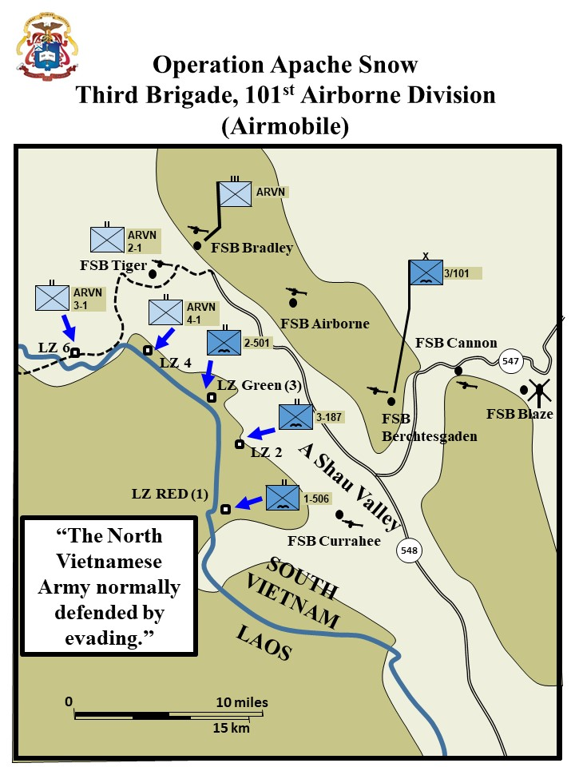

Rather than permit a substantial enemy force to reach the populated area of Thua Thien Province and Hue, which for all practical purposes had been completely pacified and resettled, the decision was made to launch a Corps level combat operation to deny the enemy re-entry into South Vietnam in strength from his sanctuary across the border from the A Shau Valley and to destroy those forces which had already been infiltrated. The 101st Airborne Division, in coordination with the 1st ARVN Division, was assigned the primary responsibility for conducting operations in the northern A Shau Valley while elements of the 3d Marine Division operated farther to the north with the mission of blocking enemy efforts to either withdraw from or reinforce into the northern A Shau.



Operation APACHE SNOW was initiated by a multi-battalion airmobile assault by three battalions of the 101st Airborne Division (1st Bn, 506th Inf; 3d Bn, 187th Inf; 2d Bn, 501st Inf) and one battalion of the 1st ARVN Division (4th Bn, 1st ARVN Regt) into carefully selected landing zones adjacent to the Laotian border. Each of the landing zones for the initial assault was selected based on the latest intelligence so as to achieve surprise and to place the assault troops into close proximity to suspected enemy locations while at the same time affording the maximum degree of security during the initial landing. All preparations for this massive airmobile assault were completed by the evening of 9 May. Ten artillery batteries were in position at five different fire bases on the high ground east of the valley to provide maximum fire support for the initial airmobile assaults as well as the subsequent ground action by the infantry battalions. The maneuver battalions participating in the airmobile assault were assembled approximately eight miles east of the A Shau Valley, near Fire Base Blaze which had been established as a complete forward supply base to support Operation APACHE SNOW.

The airmobile assault of the four battalions began precisely at 0730 hours on the morning of 10 May. A total of 65 troop carrying helicopters (UH-IH) were used for the combat assaults. This permitted two battalions to be assaulted simultaneously thus placing the maximum combat power on the ground as rapidly as possible. The assault into each of the five landing zones used was preceded by a seventy minute tactical air and artillery bombardment to ***"soften it up"***; final suppressive fires were provided by aerial rocket artillery and air cavalry gunships just seconds prior to the landing of the assault helicopters. Concurrent with the airmobile assault of the four battalions, two additional battalions of the 1st ARVN Division, which had been prepositioned on 9 May, began conducting reconnaissance in force (RIF) and sweep operations northeast and south of the general area of the airmobile assaults. During the early afternoon, one additional ARVN infantry company secured a hill top in the northern end of the A Shau to protect an artillery battery which was brought in to support the airmobile assault of another ARVN battalion (2d Bn, 1st ARVN Regt) on 11 May. Thus, by the night of 10 May, six maneuver battalions (3-US and 3-ARVN) were operating in the A Shau Valley with a seventh battalion scheduled for insertion the following morning. Each of these battalions was assigned a separate area of operations in which to search out and destroy the enemy while at the same time being prepared to reinforce any other battalion should the situation require it. The battalions were not oriented on terrain or assigned the mission to take any particular hill; rather, they were oriented on the enemy and concerned primarily with locating and destroying his forces, supplies and installations wherever they might be found.

|  |
| --- |
| **Reconnaissance In Force (RIF)**  Operation Apache Snow was called a reconnaissance in force (RIF), as the North Vietnamese locations, bases, camps, and defensive positions, would have to be found as the operation progressed. Battalions normally separated into company sized elements to conduct RIF operations, massing as a battalion as necessary. At the brigade level, airmobile assets would be used to shift battalions to large enemy locations. LZs for the battalions were selected in the hilly area west of the A Shau Valley on the Laotian border, the theory being to get US forces between the Communists and their Laotian sanctuary area, to which, upon contact, they would naturally tend to try to move. All operations were conducted within the range of pre-emplaced field artillery located at FSBs established in the hills on the eastern side of the valley and at one FSB, Currahee, built on the valley floor south of the area where the battalions were to operate. |
| McGrath, John. *The Brigade: A History, Its Organization and Employment in the US Army*. Combat Studies Institute Press, Fort Leavenworth, Kansas, 2004, 70. |

**Battle of Dong Ap Bia:** Excerpts from Wright John (MG), *Narrative of Operation Apache Snow,* 22d Military History Detachment and *XXIV Corps Historical Summary of the Battle of AT Dong Ap Bia (Hamburger Hill) 10 – 20 May 1969*. Headquarters XXIV Corps, 1971.

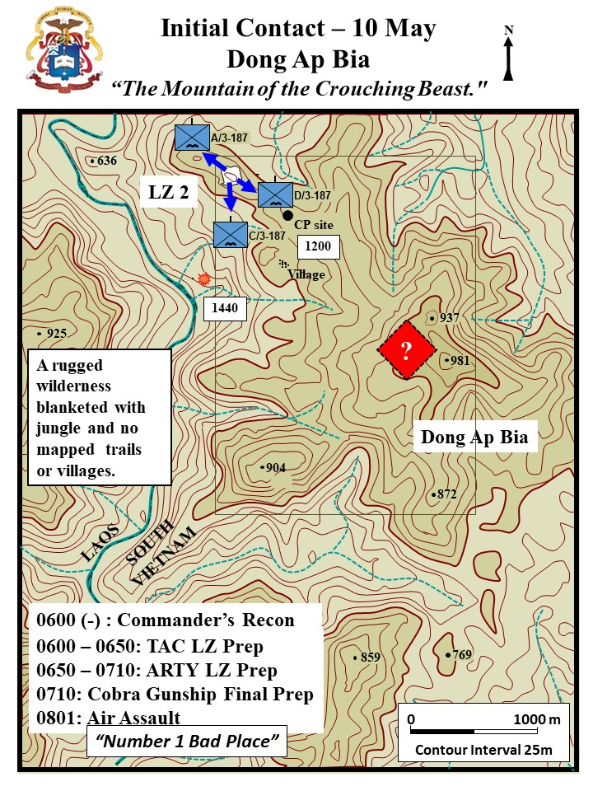

**10 May 1969**

**(Excerpt from MG Wright, *Apache Snow*)**

At H-hour, 100730 May 1969, the lead elements of the four battalions were picked up by sixty-five UH-1H helicopter from FB Blaze and moved to their respective landing zones. Prior to the combat assaults each landing zone was bombarded for seventy minutes by tactical aircraft and artillery with final suppressive fires being delivered by air cavalry gunships and aerial artillery. B, C, and D Companies in addition to the battalion’s command post, of the 1st Battalion, 506th Infantry were the first to hit the ground in the area of operations at 0812H. Once the landing zone (YC 312949) all companies began maneuver on multiple axis toward the Laotian Border

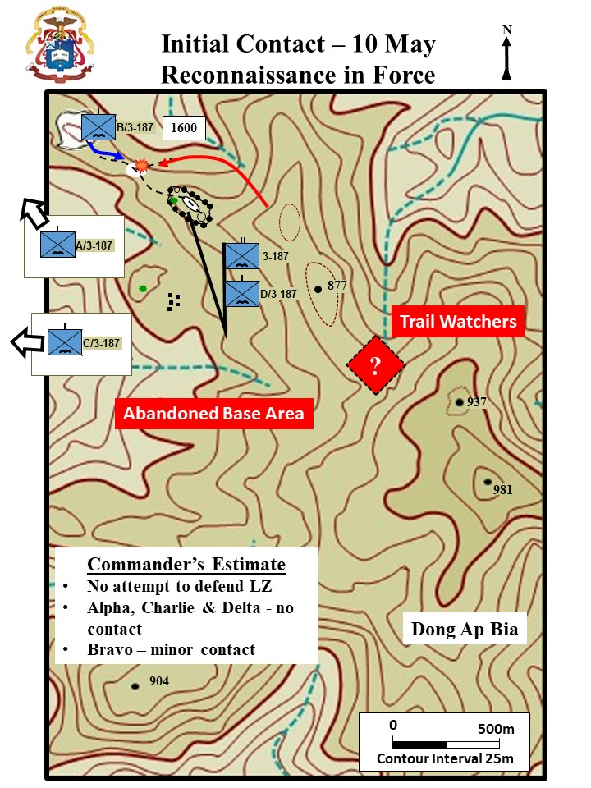

By 1600 all companies and the battalion’s command post of the 3d Battalion, 187th Infantry combat assaulted from FB Blaze to their two ship landing zone (LZ 2)…

|  |
| --- |
| **Lieutenant Colonel Weldon Honeycutt**  LTC Weldon Honeycutt, known as “Black Jack”, commanded the 3-187th IN. The unit was also known as the “Rakkasans.” The nickname came from their four-year occupation of Japan after World War II.  First Lieutenant Frank Boccia, the 1st platoon/Bravo Company/3-187 described Honeycutt as ***“short, wiry, cocky, glacier-eyed and belligerent.”***Boccia also stated he was “harsh, brutal, egocentric, and demanding.” Boccia recalled that he rarely praised and often rebuked in an abusive and scathing way. A man who ***“… was impossible to like.”*** Despite these harsh words, Boccia also stated ***“he was the paradigm of a battlefield commander… [and] if you wouldn’t follow him, you wouldn’t follow anybody.”*** Fifty years after the battle, Honeycutt would refer to Boccia as *“The finest officer that came down the pike… He was my go to guy.”* (WPCFOH, Honeycutt Interview)  Captain Robert “Bob” Harkins the Alpha Company commander also remembered Honeycutt as a hard man. Harkins stated ***“…he (Honeycutt) chewed my ass every day. I felt most every day that I was going to be fired any minute.***” However, he also remembered him as a great commander and stated, ***“He gave me a lot of latitude.”*** |
| Boccia, *The Crouching Beast, 4, 433;* West Point Center for Oral History, Honeycutt Interview; WPCFOH, Harkins Interview. |

|  |
| --- |
| **Landing Zone 2**  Landing Zone 2 was relatively clear, partly because of the heavy tactical air and artillery pounding. The surrounding area, including Hill 937 and the ridges leading up to it, was covered with triple-canopy jungle and thick undergrowth which made movement over the steep slopes extremely slow and difficult even under the best of conditions. Visibility was likewise limited by the heavy bamboo and elephant grass.  After completion of the combat assault, which was unopposed, LTC Weldon Honeycutt, in order to develop the situation, sent A Company to the northwest, C Company to the southwest and D Company up the ridge to the southeast toward Hill 937; B Company was held as brigade reserve and did not join the remainder of the battalion until 1600 hours. By noon, D Company had secured some prominent terrain on the ridgeline leading up to Hill 937. It was from this key position, approximately 1000 meters to the northwest of Hill 937, that the battalion headquarters controlled and supported operations during the period 10-21 May. After joining the battalion, B Company passed by the battalion headquarters location and continued to move up the ridge toward Dong Ap Bia. The company had moved only a very short distance when they began to receive sniper fire followed by small arms fire and two rocket propelled grenades (RPG). They responded with their organic weapons and were supported by mortars, artillery, gunships and air-strikes. In this initial contact, the company suffered three wounded while killing four of the enemy. Gunships and air-strikes continued to pound the suspected enemy positions until darkness. A and C Companies, moving generally to the west toward the Laotian border, made no contact with the enemy during the day. However, they did find significant evidence that the NVA had been in the area. One of the discoveries was an abandoned village hidden in the jungle with a significant amount of enemy supplies cached. A Hunter-Killer Team of Observation LOHs and Cobras did engage 5 or 6 NVA less than 2,000 meters west of Hill 937. |
| *XXIV Corps Historical Summary of the Battle of AT Dong Ap Bia (Hamburger Hill) 10 – 20 May 1969*. Headquarters XXIV Corps, 1971 |

The 2d Battalion, 501st Infantry. B, C, and D Companies and the battalion command post assaulted onto a landing zone (YC 288015) at 1047H while A Company secured and continued to construct FB Airborne.

The 4th Battalion, 1st ARVN Regiment which assaulted into a landing zone at coordinates YD 241041 and began operations in the immediate area of the Laotian Border.

The other battalions involved in the operations continued to maneuver in their respective zones and discovered numerous small caches containing mixed small arms, mortar rounds and crew-served weapon ammunition.

|  |
| --- |
| **BATTLE OF DONG AP BIA - HILL 937 10 - 21 May 1969**  Headquarters 101st Airborne Division, Summary of Action and Results  24 May 1969 |
| On 100844H May 1969, the 3-187th Infantry combat assaulted into LZ2 just west of Dong Ap Bia. D/3-187 immediately made contact with an unknown size enemy force. Approximately two hours later while moving from the LZ, B/3-187 made contact, returned fire and killed two NVA, Initial impressions were that the NVA were probably trail watchers, but after sustaining three wounded the battalion concluded the firing was well controlled and the stiffer resistance might be encountered. |

**11 May 1969**

**(Excerpt from MG Wright, *Apache Snow*)**

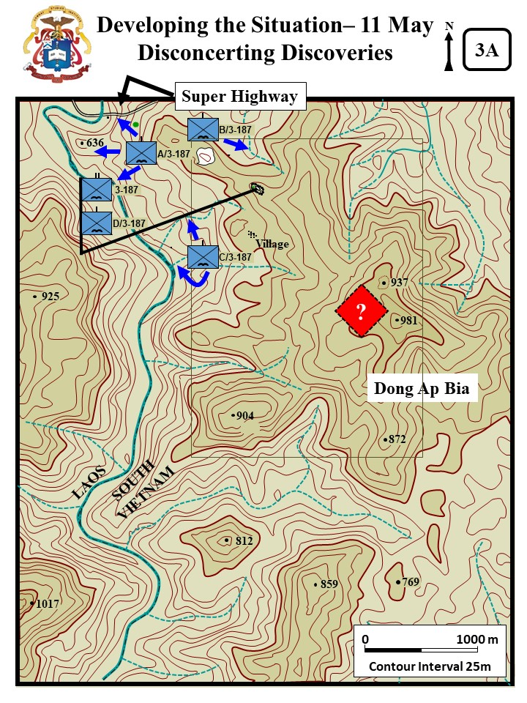

Suspected enemy bunker locations were pounded with artillery and airstrikes throughout the morning.

|  |
| --- |
| Lieutenant Frank Boccia (Bravo, 1st Platoon) recalled: ***“Before my platoon moved up the hill, fighter –bombers, and artillery helicopters bombarded its slopes with air strikes and napalm. It didn’t seem like anything could live up there.”*** |
| Diconsiglio, John. Vietnam: *Blood Bath at Hamburger Hill.* NY, NY: Franklin Watts, 2009. 18-19 |

A and C Companies continued their reconnaissance in force operations to the northwest of Hill 937 toward the Laotian border where they made no contact with the enemy but did report finding trails with fresh tracks. D Company continued as the battalion reserve.[1]

|  |
| --- |
| **Super Highway**  About 1400, A Company/3d Battalion, 187th Infantry discovered an improved road 1400 meters NW of the BN CP. They referred to it as a ***“super highway.”*** The surface was packed and the jungle above was woven together making the road invisible from the air. The road went west toward the river and Laos, and then east around the north side of the mountain. Near the river they discovered a hut with bunkers. The perceived way-stationed had an assortment of NVA clothing and equipment, garden, and chickens. There was also a still burning fire which indicated the occupants had only recently departed. |
| Zaffiri, Samuel, *Hamburger Hill, May 11-20, 1968.* Novato CA: Pesido Press, 1988. 83-84 |

While following fresh tracks up the ridge, 1st Platoon, B Company/3d Battalion, 187th Infantry found several weapons, blood trails, miscellaneous supplies, equipment, and additional enemy soldiers killed by the artillery and airstrikes. One significant find was a group of enemy documents which later identified the enemy force as elements of the 29th NVA Regiment. The documents indicated that the 29th Regiment had returned from North Vietnam in April and had been conducting reconnaissance operations between Base Area 611 in Laos and Route 548 in the A Shau Valley.

|  |
| --- |
| **The Normally Elusive Enemy**  The NVA avoiding contact was their normal procedure. However, the large amounts of abandoned equipment was not typical. Normally the enemy left nothing behind to indicate their presence. Boccia recalled that everything was, ***“Like, this way, dummy!”*** just keep coming this way we are waiting for you. Discoveries along the trail included:   * Three dead NVA soldiers. The soldiers were young with boot-camp like haircuts. Every indication was that they had not been in the jungle very long. * Two assault rifles, an RPG, and several rocket grenades. * A packet of documents and some personal letters. * Blood trails, foot prints, and bandages. * Ruck sacks filled with rice balls * A brand-new AK 47 in a leather carrying case, and a box of grenades. |
| Boccia, Frank. *The Crouching Beast*. Jefferson, NC: McFarland & Company, 2013, 289-293. |

|  |
| --- |
| Trooper Dennis Helms was Lieutenant Boccia’s radioman. He recalled, ***“We had to go slow… We knew they were leading us into an ambush… There were blood trails, equipment lying beside the trail.”*** |
| West Point Center for Oral History [WPCFOH], Helms Interview.  http://www.westpointcoh.org/search?authenticity_token=nxQ5SiZtFUZn3dMNNpOvKbs9NxlCyqGalv3SeP4bM7E%3D&search=hamburger+hill&utf8=%E2%9C%9 |

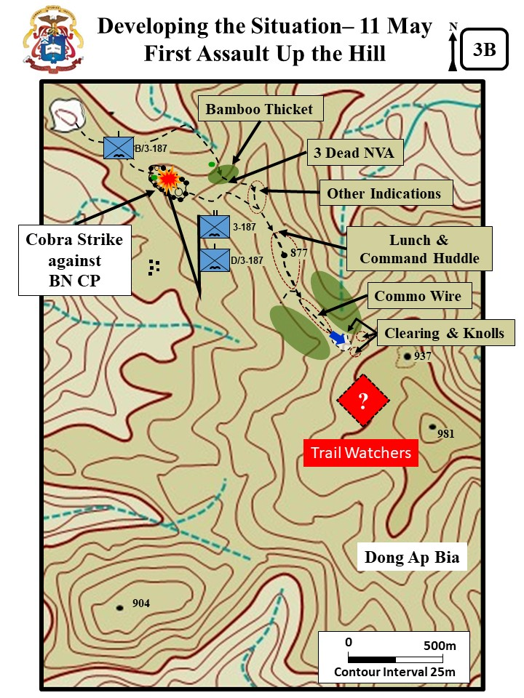

|  |
| --- |
| **Command Huddle, Broken Radio Strap and Communication Wire**  About noon, the company halted for a brief lunch break and a command huddle. At the end of the break, Captain Charles Littan directed Lieutenant Boccia to move faster. When Boccia started to move out, the strap on his radio operator’s PRC -25 broke. Boccia informed Littman of the need to pause to fix. Cpt. Littan frustrated with the slow movement and ongoing pressure from BN decided to move Lt. Charlie (Chuck) Denholm’s 4th platoon to the front. While following fresh tracks up the ridge, the company was fired on by a loan sniper that delayed their movement. About 1300, Denholm’s lead element discovered communication wire and more tracks leading up the hill. The wire was attached to the trees with insulators. The discovery troubled the Bravo leaders. The question was, if the NVA had established a communication network then just how many NVA were on the hill? |
| Boccia, *The Crouching Beast*, 293 and Zaffiri, *Hamburger Hill,* 80-84 |

Lieutenant Denholm discovered that the trail moved along a narrow razorback ridge and then through a small clearing. The steep and narrow ridge increased its incline and the flanks were precipitous. Rifleman Dennis Helms vividly remembered the razor back ridge, ***“…the vegetation was so thick [on both sides] you could not go down on the sides and if you could it was so steep you couldn’t maneuver on it.”***

|  |
| --- |
| **The Clearing**  Frank Boccia recalled, ***“…it seemed to be as a football field. In fact, it was about 20 meters across and perhaps 40 meters deep. There were a couple of trees in the middle, but for the most part it was covered by small short bushes and scrub brush and creepers. At its far end, the vegetation became much thicker. A saddle connected two small knolls that dominated the clearing; the trail zigzagged through the clearing until it began to climb again, along the face of the right-hand knoll, the southern one.”*** Behind the knolls was the summit of Hill 397. |
| WPCFOH, Dennis Helm Interview and Boccia, *The Crouching Beast*, 304-305. |

At 1624H, 4th Platoon, B Company, 3-187th made contact with an unidentified size enemy force well entrenched on the ridge line in the vicinity of Hill 937. Receiving enemy heavy machinegun, small arms, RPG, and mortar fire the company employed ARA, air strikes, and artillery support in addition to small arms fire which resulted in an estimated five NVA killed. These were discovered while the unit search the bunker complex. B Company’s lead platoon suffered three killed and nineteen wounded in the contact and was force to withdraw a short distance to regroup, leaving the wounded where they fell. The company initiated a second advance to retrieve those initially wounded and suffered additional casualties. On the third attempt, LTC Honeycutt, the battalion commander, instructed them to increase their volume of fie and push up past the wounded rather than trying to retrieve them under direct enemy fire. This was accomplished t 1645H.

|  |
| --- |
| **Lieutenant Chuck Denhom’s Fight**  The enemy were popping up from spider holes among the US platoon and shooting at point-blank range. The enemy fire seriously wounded Lt. Denholm and killed the lead two men and wounded several others. Chuck Denholm, despite his wounds, remained in the fight and tried to bring his platoon forward on line. He could not stand or hear due to his wounds – so crawled around to try to pull the wounded back. He brought up two M60 MMG gunners, both were shot down, and overwhelming enemy fire forced the platoon back. The platoon was forced to withdraw a short distance to regroup and some of the wounded and equipment were left behind. Platoon Sergeant Louis Garza took charge and maneuvered the two trailing squads forward and recovered the dead and wounded. |
| Zaffiri, *Hamburger Hill,* 87-88 |

At 1700 during a med-evac for B Company a cobra gunship accompanying the med-evac inadvertently banked and fired six rockets into the Battalion command post, D Company, and the mortar platoon leaving one killed and thirty-five wounded in the wake. The battalion commander, S2, S3, and artillery liaison officer were wounded, and most were evacuated except the battalion commander and the S3. By 1900H the wounded had been evacuated and the companies began establishing their night defensive positions. (LTC Honeycutt flown out that night to have a piece of shrapnel removed from his back and then back with the battalion before daybreak)

|  |
| --- |
| **Captain Charles Addison’s Fight**  Soon after the friendly-fire incident. A NVA 120mm mortar fired on the BN CP. It was firing from Laos and put 5 or 6 rounds into the CP. Then five NVA soldiers charged into the CP area from the jungle. The BN S-2 section led by Cpt Addison killed three of the enemy soldiers and chased the others back into the jungle. |
| Zaffiri, *Hamburger Hill*, 91 |

B Companies’ heavy contact and the documents found earlier were the first indication that a sizable enemy force might be occupying Dong Ap Bia.[2]

|  |
| --- |
| **LTC Honeycutt’s Dilemma and Estimate of the Enemy Situation**  LTC Honeycutt wanted to push Bravo back up the hill immediately. However he realized his command post was not capable of coordinating the artillery and air support needed for the attack. He then directed Cpt Littnan to establish a night defensive position. Honeycutt reviewed his enemy estimate. That morning he believed that Hill 937 was occupied by either a NVA recon party or possibly a trail watcher group. However, Bravo’s discovery of the communication wire and their subsequent fight at the clearing, and Alpha’s discovery of the road and way-station supported that a sizable enemy force might be occupying Hill 937. Possibly a reinforced platoon or possibly a company (-). He decide to:   * Cancel the Alpha and Charlie RIF in the river valley. * Alpha conduct a relief in place with Delta at the BN CP. * Delta RIF to the NE then due south up the north face of Hill 937 * Charlie now to conduct an RIF up Hill 937 to the east and parallel with Bravo * Bravo continue to develop the situation toward the top of Hill 937. |
| Zaffiri*, Hamburger Hill,* 92-94 |

The 1st Battalion 506th Infantry while maneuvering near the Laotian Border west of Ta Bat (about 5K south of Dong Ap Bia) received mixed 60mm and 82mm mortar rounds resulting in seventeen wounded, all of which were later evacuated. The 2d Battalion, 501st Infantry, on the other hand, encountered minimal contact during the day (about 7K NW of Dong Ap Bia).

**12 May 1969**

**(Excerpt from MG Wright, *Apache Snow*)**

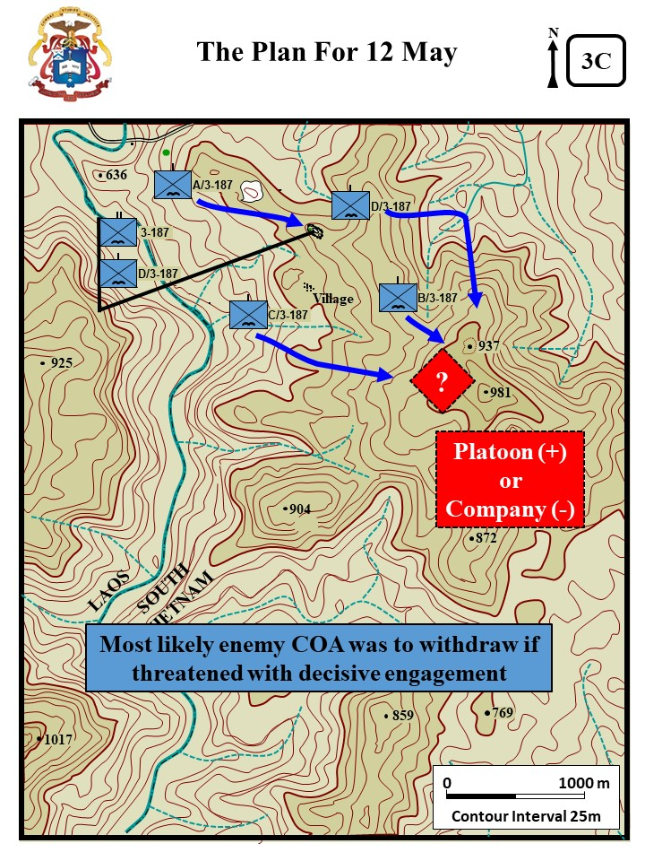

Realizing that he had found the enemy on Hill 937, although he was still unable to determine the size of the force, LTC Honeycutt decided to employ all of his companies to further develop the situation. A Company became the battalion reserve replacing D Company which moved out to the northeast turning toward Hill 937 later in the day. C Company turned around and began moving to the east to join B Company. B Company continued to maneuver against the well-disciplined enemy force which was dug in about 200 meters to their front. As on previous days, the hill was continually bombarded with airstrikes and artillery, including 500 and 1000 pound delayed fuse bombs and napalm, in an effort to dislodge the enemy from his fortified positions.[3]

On 12 May, the 3-187th continued their push through the thick bamboo and elephant grass along the rough ridges of Dong Ap Bia. Air strikes were completed at 0804H in support of B Company’s advance up the hill and C Company’s advance to the southwest of B Company. At 0913H B Company began receiving sniper fire from their rear and by 0921H they were receiving intense automatic fire from the front and incoming mortar rounds. To aid in the evacuation of the wounded the battalion commander requested engineer support to blow a landing zone for B Company. Attempting an insertion at 1024H the engineer ship was hit by RPG fire causing it to crash and burn resulting in seven casualties.

B Company continued to maneuver against the well-disciplined force, estimated at two companies, which were dug in about 200 meters to their front. The battalion called for ARA and artillery fire in order to dislodge the enemy from his fortified position, but the enemy held fast and throughout the day the 3-187th continued to receive heavy automatic weapons and RPG fire interspersed with mortar fire. In the afternoon, battalion suspended B Company’s attack. The bombardment of the hill resumed with heavy air strikes consisting of 500 and 1000 pound bombs (high drag and delayed fuse), in addition to napalm and artillery fire.

|  |
| --- |
| **Lieutenant Frank Boccia’s 1st Platoon Fight**  Soon after the strikes, 1st platoon (B/3-187th) moved out with 2 squads up and one trailing. It took the platoon 35 minutes to move two hundred meters back to the clearing. At the clearing the men had to move on their hands and knees because of the steep incline. Soon after moving into the clearing they were engaged, A HMG also engaged the plt from the right knoll. Boccia remembered, ***“Two, perhaps, three claymore mines were blown immediately ahead of us; the fragments whined overhead, into the trees behind us. Then the familiar crackle of Ak 47s spat out of the woods, and , with paralyzing intensity, the solid bass hammering of the .51 caliber.”*** The platoon soon spotted a bunker and brought forward a 90mm Recoilless Rifle (RR) to engage the bunker.The RR crew engaged and destroyed the bunker, but then from another nearby bunker the NVA engaged and destroyed the RR – wounding the two crewmen. Boccia recalled, ***“I was looking directly at the 90mm team when, to my horror, an RPG hit directly in front of them. The black barrel of the gun went high in the air, emerging out of a cloud of dirt, leaves, and explosives. I saw a helmet go flying; then Clifton and Nelson appeared, their bodies rolling down the slope.”*** Fortunately both men survived with only scratches and bruises. The initial RPG served as a signal and then a volley of RPGs hit the lead to squads wounding six men. The platoon medic rushed forward, but was also wounded. Boccia remembered, ***“The first RPG was a signal. Suddenly, countless NVA soldiers appeared from spider holes, firing volleys of RPGs. We hugged the ground, but grenade rockets kept coming. About 30 NVA soldiers laid down a blanket of machine-gun fire. Tree limbs and branches fell around us. We tried to shoot back, but the assault was too intense. I couldn’t even lift my head.”*** Lt Boccia estimated his two squads were in contact with at least 20-30 NVA and he received permission to pull back.The platoon returned to its start point dragging its wounded. |
| Boccia, *The Crouching Beast*, 317-319 and Diconsiglio, *Blood Bath, 24* |

|  |
| --- |
| **NVA MDH-C40 Claymore Mine**  The MDH-C40 is an North Vietnamese copy of the US M18 Claymore directed fragmentation antipersonnel mine. The MDH-C40 is similar in appearance to the US M18. The Vietnamese mine has a metal case instead of the plastic case of the M18. Although the MDH-C40 and the US M18 mine bodies are similar in size, the MDH-C40 contains 800 grams of TNT which will yield twice the blast effect of the M18 mine and a greater fragment range. Length: 228mm; Weight: 1.66kg; Explosive: 800g; Range: 300m. |

|  |
| --- |
| **Lieutenant Marshall Eward’s 2d Platoon Fight**  After the repulse of the 1st Platoon, LTC Honeycutt coordinated a massive strike against Hill 937 to support another move by Bravo to get up the hill. About 1230, fighter bombers hit the hill with 1,000 pound bombs with delayed fuses. Then 10 artillery batteries pounded the hill for 30 minutes. Next, two pairs of Cobra gunships hit the hill with rockets and strafing. At 1400, the fighter-bombers returned with more 1,000 pound bombs. About 1400, Lieutenant Eward’s 2d platoon took the lead. Eward was confident that the heavy fires brought against the hill had cleared the way. Nevertheless, the platoon advanced cautiously, but soon after they moved into the clearing a storm of fire forced them back. Eward’s men did recover the 90mm RR left behind by Boccia’s men. He later personally handed it back to Lt. Boccia and remarked, ***“Excuse me, ma’am, did you drop this.”*** |
| Zaffiri, *Hamburger Hill*, 105 and Boccia, *The Crouching Beast*, 327 |

By late afternoon, C Company had moved to a position approximately 200 meters south of B Company. The company dug in for the night, having sustained eight wounded in an enemy RPG ambush. Delta was also unable to get into position to support a battalion attack. Although sniper fire harassed them periodically, it was the terrain that proved to be a major problem. All told the company managed to move only 500 meters and was still well short of where they needed to be to turn south up the north face of Hill 937.

LTC Honeycutt decided to forgo any more attacks until the 13th when Charlies and Delta would be position for the BN to execute a 3 company attack. The bombardment of the hill resumed with heavy air strikes consisting of 500 and 1000 pound bombs (high drag and delayed fuse), in addition to napalm and artillery fire. In the battalion sector, the night was quiet. Artillery was placed on Hill 937 and its ridges throughout the night.[4]

Meanwhile, the other battalions (2-501st & 1-506th) continued to conduct reconnaissance in force operations throughout their areas of operation encountering limited contact. B Company, 1-506th while maneuvering in the vicinity of coordinates YC 309941, encountered three NVA, killing one and capturing his AK-47. While on reconnaissance in force operations in the immediate area of the Laotian Border 3/1 ARVN Battalion discovered a small cache of miscellaneous equipment and weapons (eight individual and twelve crew-served). Simultaneous with the maneuvering of the battalions on the ground A Troop, 2d Squadron, 17th Cavalry conducted air reconnaissance in support of the ground forces throughout the area of operations.

|  |
| --- |
| **Fire Support Base Airborne**  Late night 12 May and early in the morning 13 March 1969, two company-sized elements of the enemy’s 806th NVA Battalion and K12 Sapper Battalion infiltrated FSB Airborne, supported by mortar and rocket propelled grenade fire. Stationed at the firebase were three field artillery batteries: C/2-11th Artillery, four 155 mm howitzers; C/2-319th Artillery, four 105mm howitzers; and a composite battery from B and C/2-319th Artillery, four 105mm howitzers. The firebase was defended by Company A, 2-501st Infantry. The defenders drove off the attack with the attacking force suffering heavy casualties, but five howitzers were damaged and 22 American soldiers were killed and another 61 wounded. With enemy forces obviously in the area of FSB Airborne, the brigade commander pulled the rest of the 2-501st out of its area on the Laotian border and airlifted it to FSB Airborne to commence RIF operations near the firebase.  Lt. Boccia remembered his thoughts the next morning when he heard about Firebase Airborne, ***“[I was] stunned, my mind began doing the math. The 6th NVA [Regiment] at Dong Ngai;* [FSB Airborne] *the 29th [NVA Regiment] here, a regiment here, a regiment there… what had we gotten ourselves into?”*** (Boccia, 341) |
| McGrath, *The Brigade,* 72 and Boccia, *The Crouching Beast*, 341 |

**13 May 1969**

**(Excerpt from XXIV Corps Historical Summary)**

The situation remained relatively unchanged on 13 May. B and C Companies, now generally abreast but separated by several hundred meters, resumed their movement up Dong Ap Bia.

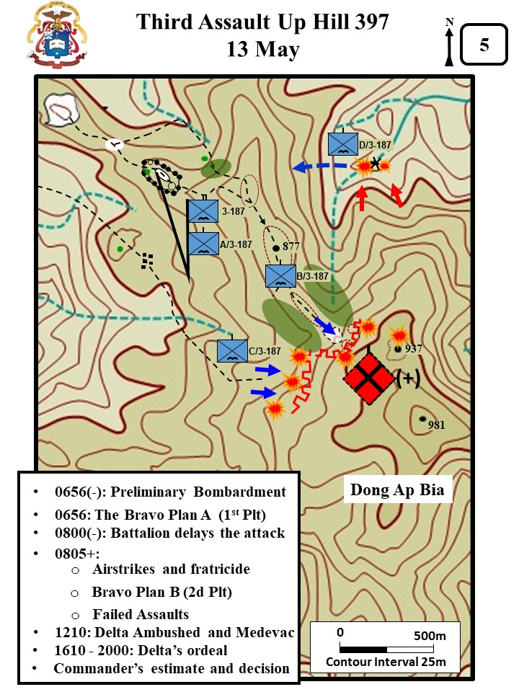

|  |
| --- |
| **Captain Littan’s Plan A and the Fratricide Incident**  Captain Littnan (B Company, 3-187th) planned to try to trick the enemy with a fake bomb run. At 0656, Cpt. Littnan and Lt. Eward (2d Plt) crawled forward and marked the enemy bunker line with smoke. Fighter-bombers then hit the target with 1,000 pound bombs with delayed action fuses. The Bravo 1st platoon (LT Boccia) was then told to go forward but stop 75 meters short of the bunker line. Cpt Littnan planned to hit the bunker line with another wave of fighter aircraft with 1,000 pound bombs. A third wave would then come in to force the NVA into cover, but not drop bombs. Boccia was then to rush forward into the bunker line.  Sometime before 0800, Battalion delayed the assault onto mountain because of problems with Charlie getting into position. Charlie moved up a draw and received heavy fire from two sides. Battalion diverted the fighter-bombers planned for Brave to support Charlie. The airstrikes would come in between Bravo and Charlie.  At 0805, the first strike went in and Lieutenant Boccia reported that the strike was dangerously close to his platoon. Cpt Littnan confirmed with the FAC that the bomb was on target. After the second attack run – Boccia again reported the bomb was to close. Boccia reported, ***“That shit is landing too close… I know it is… We’ve got shrapnel falling all around us.”*** Again, Cpt Littnan confirmed with the FAC that the bomb was on target and for Boccia to keep his head down. The next bomb blew down trees in Boccia’s area. Sp. 4 Phillip Nelson was hit in the side with shrapnel. Boccia tried to stop the next plane from coming in but was unsuccessful. The bomb again blew trees down in the platoon area. Again Littnan and Boccia argued whether or not the bombs were too close to the 1st Platoon. Cpt Littnan insisted that they were not to close. Moments later Boccia angrily reported: ***“I just took a KIA from that bomb that landed nowhere near us.”***Cpt Littnan ordered Boccia off the net. He wanted to confirm the incident and did not want the FAC and fighter-bomber pilots to become overly cautious. Littman sent the First Sergeant forward to investigate, and he confirmed that a soldier (PFC Myles Westman) had been killed, but that the soldier had moved to the top of the ridge between the two companies to watch the show and was not wearing his helmet. Nonetheless, Boccia’s platoon morale was shattered. Rifleman Helms recalled, ***“It affected everyone in our platoon…he [Pfc Myles Westman] was such a good guy.”*** |
| Zaffiri, *Hamburger Hill*, 125-128; Boccia, *The Crouching Beast*, 358; WPCFOH, Helms Interview. |

Artillery support was continuous. The forward air controllers were always overhead and did a magnificent job of placing airstrikes on enemy positions as pointed out by the battalion commander who was either on the ground with the companies or flying at low level overhead so as to get a better view of the situation. Helicopter gunships were likewise overhead throughout the day and responded to every call from the ground commanders. Although the enemy fire was continuous and they suffered some casualties, B and C Companies continued maneuvering toward Hill 937.

|  |
| --- |
| **Captain Littan’s Plan B**  Captain Littnan moved Lieutenant Eward’s 2d plt to the front to take the lead and advance resumed. Again, Bravo could not push past the clearing and the two knolls. Eward had two squads forward. However, the enemy came out of their holes and trenches, and counterattacked with 20 to 30 men. Eward’s lost three wounded and retreated. Littnan was at a loss of what to do next. The enemy had been bombed, napalmed, and heavily bombarded with artillery for 3-days and showed no sign of giving up the fight. |
| Zaffiri, *Hamburger Hill*, 130 |

C Company also met heavy resistance and could not make any progress up the hill.As a result of the day's action, the battalion had suffered 33 men wounded and four killed, numbers which would have been considerably higher had it not been for the intensive and continuous pounding of the enemy positions by the artillery, gunships and tactical air.

In the afternoon, D Company finally reached the bottom of the ravine and crossed over a boulder strewn creek (about 900 meters north of B Company). The lead platoon received mortar and RPG fire wounding seven men. A med-evac helicopter, while extracting wounded from D Company (1536H), was shot down by small arms fire, resulting in six killed and one wounded. The third platoon of A Company moved to link up with D Company at the crash site and assisted in the evacuation of the wounded back to the battalion headquarters.[5]

|  |
| --- |
| **Captain Luther Sanders’ Ordeal**  By 1610, the company had re-crossed the creek and was heading back up toward the battalion CP. They carried out their wounded but had to leave the dead. Captain Sander’s remembered*,* ***“It was the most exhausting, physical day…we had to get these [wounded] guys up the hill.”***By 2000, they were 600 meters short of the BN CP. But it started to rain and they could no longer move up the 45 degree slope. The company formed a night defensive position (NDP). They had to wait till the next day to complete the move to the BN CP and evacuate the wounded by air. |
| Zaffiri, *Hamburger Hill*, 132-143; WPCFOH, Sander’s Interview. |

All the companies establish night defensive positions. They continued to detect enemy movement during the early evening and a Spooky aircraft (C-47 equipped with miniguns) was brought on station to engage the enemy sightings. Artillery continued to pound the hill during the night. After the day's action, the battalion commander was convinced that the NVA was occupying Hill 937 and the surrounding ridges in considerable strength? Possibly a reinforced company conducting a delay action to allow the enemy to break contact. He made his plans for the following day accordingly.

Meanwhile, the 1-506th continued search and destroy missions in its assigned area of operations moving northwest along high ground checking extensively along the slopes of the A Shau Valley. During the day, A Company found eight huts, which were considered to be part of a possible staging area, and small amounts of ammunition. While searching the cache area discovered the previous day, 3/1 ARVN Battalion found a large cache consisting of eight vehicles, seventy-eight individual, and twenty-five crew-served weapons.[6]

**14 May 1969**

**(Excerpt from XXIV Corps Historical Summary)**

On 14 May, 3-187 Infantry made a concentrated attempt to push the enemy off Hill 937. The plan was for the companies to approach the hill from three different directions, B Company from the west, C Company also from the west but up a small ridge 150 meters south of B Company, and D Company from the north.

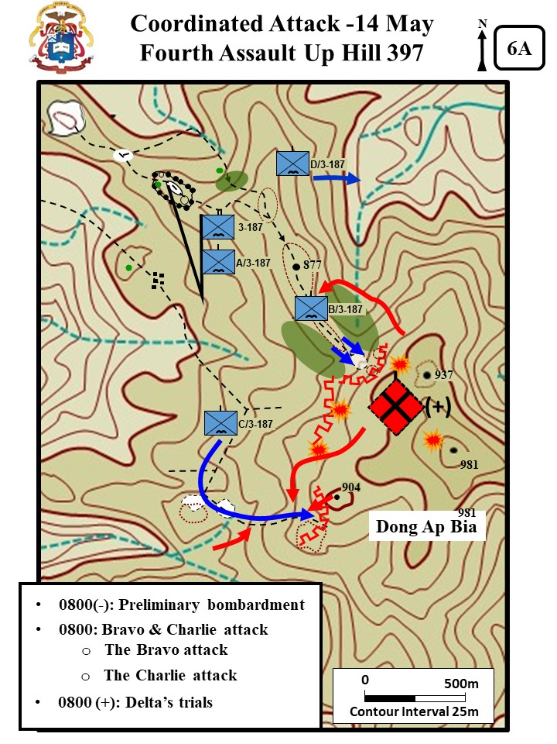

As usual, the forward air controllers arrived early and began to bomb the enemy locations in preparation for the coordinated attack; each of the companies was supported by a separate artillery preparation on their planned route of advance. The attack kicked off as planned, and in spite of the heavy artillery and air preparation, the companies immediately began to receive enemy fire.

|  |
| --- |
| **Bravo’s Attack**  Bravo attacked with two platoons online. Again the attack bogged down when they tried to push through the clearing and over the knolls. Eward’s platoon had three squads on line and when about 10 meters into the clearing the NVA detonated mines in the trees that wounded 4 men. Eward’s platoon regrouped and moved forward again. Again the NVA detonated mines and wounded three more men. Eward then reported that he could not advance. At the same time SFC Louis Garza’s 3d platoon was advancing parallel to Edward, but also could not make any headway. While two of Bravo’s platoons advanced up the hill, the NVA attack Lt. Boccia’s 1st Platoon that was guarding the LZ and bring ammo forward. Captain Littnan made the decision to pull back both of the lead platoons and regroup. |
| Zaffiri, *Hamburger Hill*, 146-148 |

C Company reported movement to his west and south. As he habitually did, LTC Honeycutt instructed the company commander to move somebody toward the suspected enemy location, to watch his flanks, to use maximum reconnaissance by fire and to stay spread out. He kept artillery, airstrikes, mortars and gunships striking the enemy. Although the resistance was exceptionally heavy, C Companies continued to push toward the top of the hill. At 0930, CPT Dean Johnson (C Company) reported that he was being fired on from all directions and would have to pull back.

|  |
| --- |
| **Charlie’s Attack**  Charlie maneuvered further to the south to avoid the bunker line that had stopped them on the previous day. Lieutenant James Goff’s 3d Platoon moved up the hill with 2 squads online. At the edge of the mountain they engaged bunkers with RR fire and destroyed three bunkers. The platoon moved through the bunker line into a saddle. Goff moved his men into the saddle and up the western face of Hill 900. The platoon had six wounded as they fought their way through the bunker line. At 0903, CPT Dean Johnson reported he was 40 meters from the top of Hill 900. However, the enemy counterattacked. One group swarmed down the Hill straight into 3d Platoon. Another group slipped down Hill 937 and poured fire into the platoon’s flank. A third group, which had hidden in a large draw, maneuvered against the platoon’s rear. At 0931, Johnson reported that 3d platoon had 2 dead and 15 wounded, and that he was withdrawing. LTC Honeycutt denied the permission to withdraw and order Johnson to get his other two platoons into the fight. |
| Zaffiri, *Hamburger Hill*, 148-151 |

B Company moved its 1st Platoon to the front to resume the attack.

|  |
| --- |
| **Lieutenant Frank Boccia’s Dilemma**  Boccia was worried about the morale of his men. He remembered, ***“I wondered – for the first time – how they would respond. They were tired and afraid, never a good combination.”***When Boccia briefed his platoon they were upset that they were being asked to attack the hill again. One man stated, ***“That f---ing Honeycutt wants to get us all killed”.***Another stated, ***“If that sonofabitch want to take this f---ing mountain so bad, why don’t he do it himself.”*** When it was time to move out there was hesitation. However, the squad leaders took over and told their men, ***“Okay, get your shit. Let’s go. Lieutenant said move, so move.”*** As they moved out, the lead squad leader walked beside the Lieutenant and asked ***“Whatta we do when we get up there.”*** Lt Boccia responded back with, ***“We kick the f---ers off the hill.”***The squad leader laughed back. ***“Oh. Okay. It’s good to have a plan, ya know.”***All the men around then laughed and passed the work back that the Lt said were are going to kick the f----ers off the hill. Lt. Boccia remembered he thought to himself ***“God bless NCOs”*** |
| (Boccia, *The Crouching Beast*, 378-380 |

Before the attack could be executed, battalion directed a new mission and directed that Boccia’s platoon be sent to assist C Company.

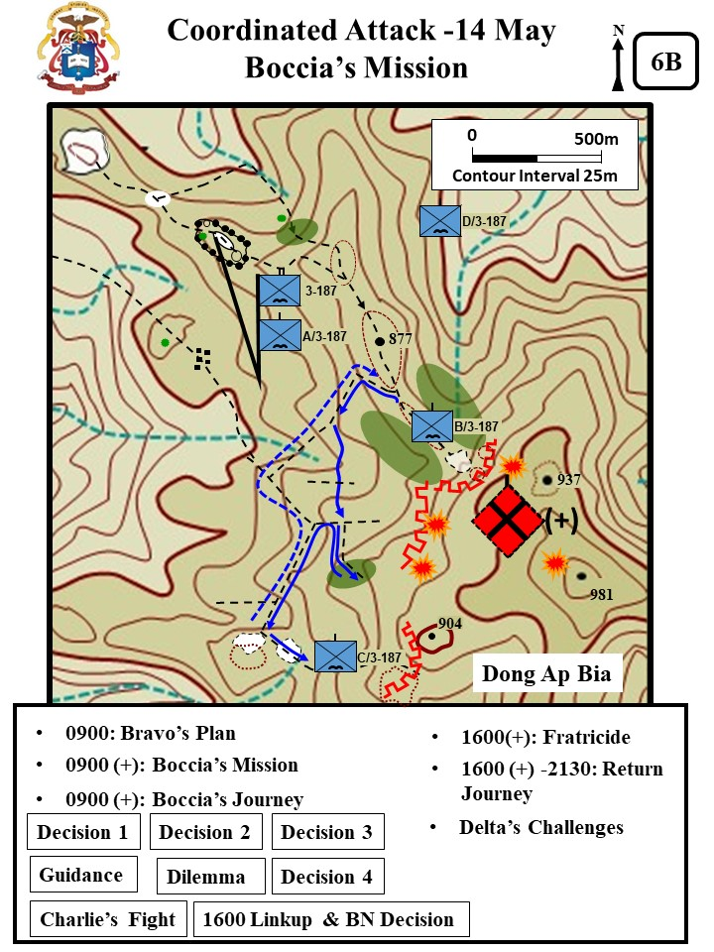

|  |
| --- |
| **Boccia’s Mission**  Upon receipt of the new mission, Boccia unconsciously asked out loud – ***“why me.”*** Captain Littnan responded. ***“Because, Black Jack* (LTC Honeycutt) *requested it. His exact words were: send that big-headed wop over there.”***   * **Decision #1:** Time critical - drop packs at the NDP, bring water, extra ammo, and medical supplies. * **Decision #2:** Ignore east/west trails, push south, cross country if need be. * **Decision #3:** Discovered a trail to the south and decided to follow it.   About 0930, Boccia could hear that Bravo had resumed the attack. SFC Garza’s 3d Platoon would eventually seize a foothold in the enemy’s second bunker line.   * **BN Guidance:** LTC Honeycutt called Boccia directly to check on his progress. Boccia recalled that most of his past conversations with LTC Honeycutt usually consisted of heated counseling on some failure on his part to meet the commander’s standards. In the radio call Honeycutt directed, ***“I want you there ASAP. And BO – you do what you have to, to take care of things. Understand?***” Boccia was concerned and confused about the guidance ***“do what you have to do”*** and also somewhat perplexed because Honeycutt had never called him ***“BO.”*** * **Dilemma**: The trail veered to east and into a thick bamboo thicket, and the point man heard voices. Boccia remembered, ***“The voices were so low I couldn’t recognize them, as either English or Vietnamese… But suddenly, several voices broke out, loud and shrill, followed immediately by the chatter of small arms fire and the gassy snap of an RPG being fired.”*** (The RPG confirmed it was an enemy unit). Boccia recognized he was within 20 to 25 meters of an NVA unit firing at Charlie on the ridge just above them. Boccia considered several options:   + - Option #1: ***“I could mount a direct attack, trying to punch through the bamboo.”***     - Option #2: A grenade attack. ***“This idea appealed to me; the havoc 25 grenades, launched simultaneously, could wreak was substantial.”***     - Option #3: Return to the east west trail and maneuver onto the enemy’s flank. ***“It would take time. What if I did so, found and killed a handful of trail watchers or a small RPG tem, and in the meantime Charlie Company was overrun…”***     - Option #4: Return to the east west trail and move to the west and find another route to get to Charlie. **“*The fourth option was the safest and most consistent with my orders.”***   + **Decision #4**: He decided to go with Option #4. Boccia remembered that, ***“This whole [decision making] process took no more than 15 or 20 seconds at most.”*** |
| (Zaffiri, *Hamburger Hill,* 154-156; from Boccia, *The Crouching Beast*, 381-384. |

|  |
| --- |
| **Charlie’s Fight**  While Boccia moved along the trial toward his objective the situation at Charlie company had gone from bad to worse. Lieutenant Donald Sullivan’s 2d Platoon came forward to support Lieutenant Goff’s 3d Platoon. It soon received heavy fire and within about 30 minutes the 2d Platoon had several killed and wounded. Participants remember that Lt. Goff fought like a mad man. He continually engaged enemy bunkers with a M79, and his personnel example kept the platoon in the fight and not running to the rear. In a short time, the two platoons had 30 wounded and two killed. Captain Johnson again asked permission to withdraw. During the withdrawal, the two platoons took more casualties with attacks against their stretcher parties. Johnson brought forward his 1st platoon (Lt. Joel Trautman) to help with the withdrawal. Trautman came forward and found the company leadership traumatized and took over command of the withdrawal. Trautman remembered, ***“I crawled up to him (the company commander). I asked him what he wanted me to do, and he was non-communicative. He was not talking to me.”***Trautman then moved forward to organize the company. He recalled, ***“[The 18th] was the worst day of my life. The weight of the world was on my shoulders.”*** About 1400, Trautman started to pull the remnants of the company back into a defensive position.  At 1600, Lieutenant Boccia (Bravo) linked up with Charlie at their company CP/ forward LZ. At the LZ, He found 20 to 30 dead and wounded, and minimal security. He put two squads around the clearing for security and then sent one squad forward to find out what was going on. Boccia remembered that, ***“I felt my stomach flip. Jesus. Charlie Company had disintegrated. . Now I understood Black Jack’s words… You do what you have to, understand?”***In time, Boccia discovered that the company was preparing to evacuate its First Sergeant, two platoon leaders, the company XO, two platoon sergeants, six squad leaders and forty enlisted men.  Honeycutt spoke by radio with Lt. Boccia, ***“Soon as you get all the wounded out, I want you to load up as much gear as you can, and then burn the rest. Then move back to Bravo’s NDP area. You tell Charlie Six I want him and the rest of Charlie with Bravo tonight.”***  At about 2130, Lieutenant Boccia and the remnants of C Company joined with B Company CPT Littnan counseled Boccia**, *“Before you think too badly of them, remember what they went through… You never know. Everyone breaks, sooner or later. Everyone. Most of us are just lucky enough not to be in Jessup’s (Johnson) position… Don’t judge Jessup (Johnson) until you’ve been there.”*** [In his book, Boccia changed Johnson’s name to Jessup]. |
| Zaffari, *Hamburger Hill*, 151–161; WPCFOH, Trautman interview. Boccia, The Crouching Beast, 389-391. |

|  |
| --- |
| **Delta’s Challenges**  Delta’s attack up the north face of Hill 973 never came about. The company did not arrive back at the creek at the base until 1354. They had been slowed by the treacherous terrain and harassing enemy fire. While recovering the dead from the previous day they were hit MG fire and RPGs. The enemy fire inflicted an additional 10 wounded in Delta, five of which were litter cases. CPT Sanders called for artillery, airstrikes, mortars and gunships, and after 20 minutes the enemy backed away. About 1430, Sanders requested and received permission to cancel his portion of the attack and bring his wounded back. |
| Zaffiri, *Hamburger Hill,* 162 |

In order not to expose B Company unnecessarily, the battalion commander directed the company to give up the section of the bunker line they had captured and pull back to their night defensive position. He directed C Company to move to and set up for the night with B Company. While sporadic contact continued, the remainder of the day was devoted primarily to the evacuation of wounded, resupply and preparation of the night defensive positions.

Throughout the day Light Observation Helicopters (nicknamed the “Loach”) used as med-evacs were called in to evacuate all seriously wounded from a small landing zone on the ridge down to the battalion landing zone. This method of shuttling the wounded worked well and drew much praise from the men on the ground.[7]

|  |
| --- |
| ***“Crazy”* Eric Rairdon**  One of the Loach pilots was Warrant Officer ***“Crazy”*** Eric Rairdon. He had earned the nickname ***“Crazy”*** from his frequent disregard for weather minimums and long hours supporting the battalion. He stated that in his association with the Rakkasans, ***“I got to know the people.”*** The Rakkasans believed that Rairdon could get to them when no one else could. Lieutenant Boccia stated, *“****Pilots are, by my definition, crazy…[Rairdon was] “probably clinically insane.”***Rairdon in getting the wounded out would somewhat overload his tiny helicopter.   * One ambulatory casualty in the co-pilot seat. * One stuffed behind the seats. * And one each strapped into stretchers on each side.   Every time Rairdon came back he brought ammunition, food, and water. Rairdon made multiple shuttle runs on the 14th, and he remembered taking fire, ***“They were shooting at me, but I was extremely lucky that they were missing consistently.”*** |
| Boccia, *The Crouching Beast*, 335,355, 376 and 388; WPCFOH Rairdon Interview. |

There was no letup in the artillery and air bombardment of the enemy, however. A rapid count indicated that an estimated 76 enemy had been killed during the day by both small arms' and airstrikes. The 3-187th lost five killed and 58 wounded. Based on the day's contact, the battalion commander assessed the enemy strength on the hill as being from 2 companies to a battalion (-). He developed plans to hit the enemy positions again on 15 May, hopefully before the enemy had an opportunity to reinforce. His plan was for A Company to relieve C Company on B Company's southern flank and to attack from a more southerly direction; B Company was to attack again essentially along the same route due to the limited avenues of approach up the hill; and D Company, operating to the northeast, was to continue attacking in that area.

The brigade commander, who had been following developments closely, to include visiting the 3-187th on the ground, determined that additional forces would be required in order to take the hill. Accordingly, he ordered, the l-506th, which had been operating to the southwest of Hill 937, to begin moving toward the hill to assist the 3-187th.

|  |
| --- |
| **OH-6A CAYUSE** |
| **Mission:** visual observation and target acquisition, reconnaissance**,** command and control; **First delivery:** 1966; **Rotor diameter:** 26'4"; **Length:** 30'3"; **Basic weight**: 1,157 lbs.; **Payload:** 930 lbs.; **Crew:** 1; **Passengers:** 3; **Cruise airspeed:** 100K; **Maximum airspeed:** 130k. |
| CMH Pub 90-4, VIETNAM STUDIES AIRMOBILITY 1961-1971, 275 |

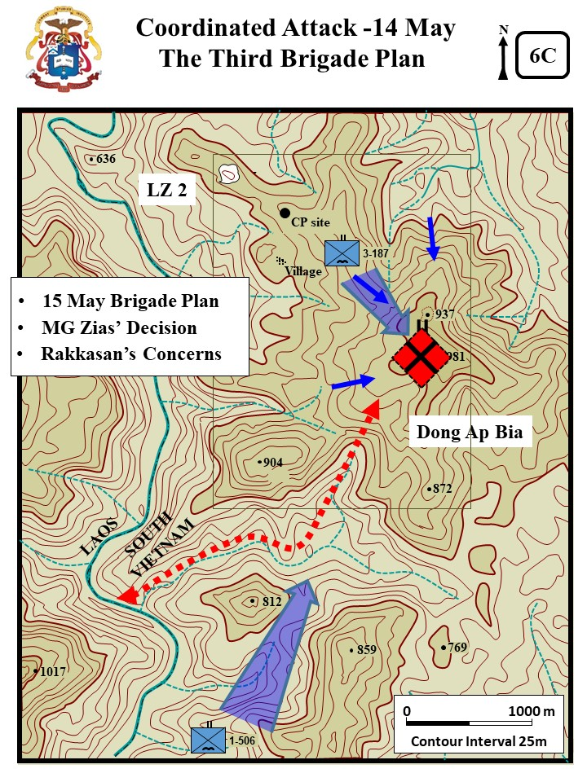

|  |
| --- |
| Colonel Joseph Conmy’s Intent  On the afternoon of 14 May, Col Conmy ordered the l-506th, which had been operating to the southwest of Hill 937, to move 4,800 meters to the north to assist the 3-187th. He was concerned that the enemy was reinforcing Dong Ap Bia through the draw SW of Hill 937 that led down to the river and Laos. Col Conmy wanted 1-506th to move in and control that draw by the morning of 15 May. |
| Zaffiri, *Hamburger Hill,* 167 |

The other maneuver battalions involved in Apache Snow continued to accomplish their search and destroy missions in the area of operations encountering light enemy resistance and many contacts with enemy trail watchers.[8]

**15 May 1969**

**(Excerpt from XXIV Corps Historical Summary)**

|  |
| --- |
| **Honeycutt’s Dilemma**  LTC Honeycutt faced a dilemma when he received word that 1-506th was not in position to attack the south slope of Dong Ap Bia or to interdict the large ravine leading to Laos (they had only been able to move 1500 meters of the 4800 meters needed). He could attack on his own again, or he could hold his position. Honeycutt decided he needed to keep the pressure on the enemy while brigade moved the 1-506th into the fight, he therefore rearranged his companies to continue the assault. |
| Zaffiri, *Hamburger Hill*, 175. |

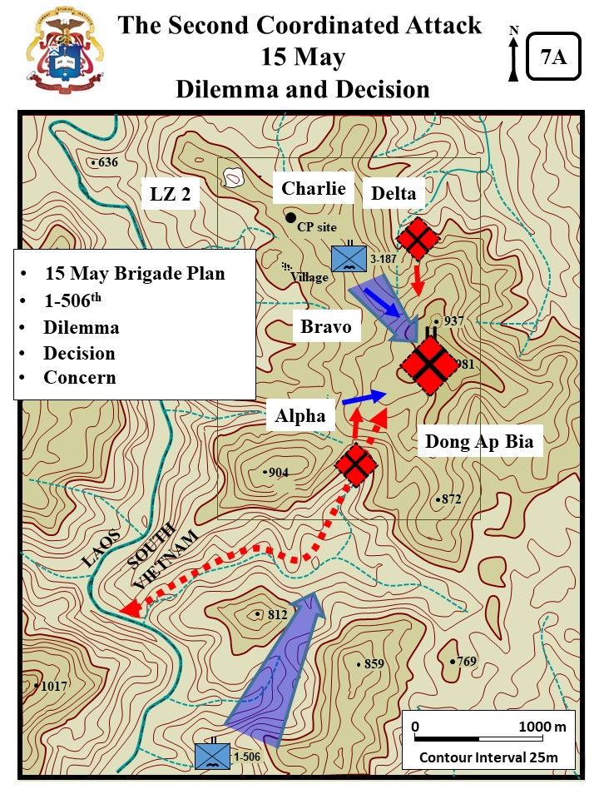

After completion of the exchange between A and C Companies, the two line companies (A & B) began their move back up the ridges of Hill 937. As on previous days, airstrikes and artillery bombarded the hill throughout the day.

|  |
| --- |
| **D Company**  Delta reported that they were still struggling to evacuate their dead and wounded and would not be able to participate in a morning attack against Hill 937. |
| Zaffiri, *Hamburger Hill*, 175 |

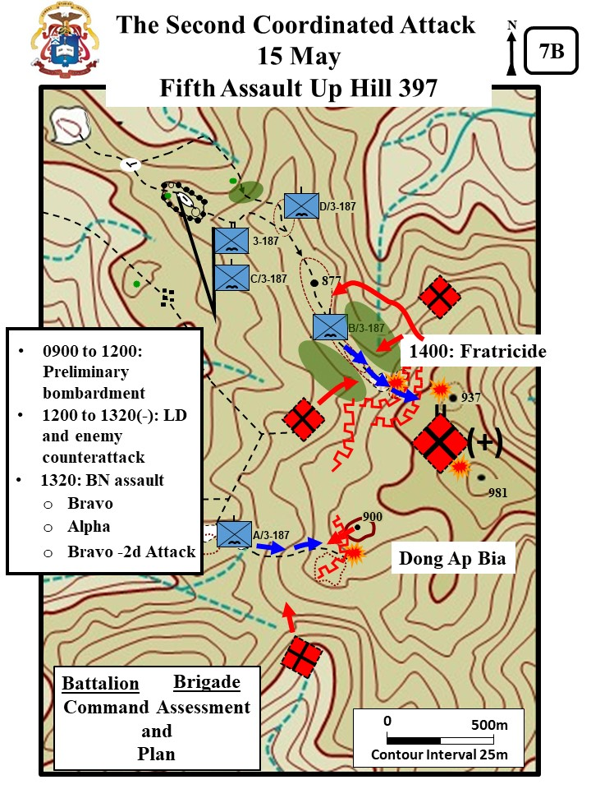

By 1300H all companies were in extremely heavy contact and suffering casualties. The enemy troops skillfully employed command detonated claymore mines which had been emplaced during the night resulting in several US casualties, particularly in B Company. Even though the enemy resistance was determined, the companies continued to advance and by 1400 hours, A and B Companies were fighting their way through the first line of bunkers. B Company requested an ARA strike to suppress heavy enemy fire to their front. A Company was on the right of B Company with C Company approximately 200 meters to the left when the ARA arrived on station at 1400H. Instead of coming in from the rear of B Company and finding its target on the hill, the ARA ships came from the right overflying A Company and raked the lead platoon of B Company with rockets knocking out C the company's command group; two members of the company were killed and 14 wounded, including the company commander. [9]

|  |
| --- |
| **NVA Counterattack**  The NVA then counter-attacked with enemy forces hitting the flanks and also working around to the rear to hit the LZ. Lieutenant Boccia (acting company commander) decided he could not continue the attack and instead organized a defense against the enemy counter-attack. When asked for his situation, Lt Boccia reported, ***“We’re in trouble. Two Six (2d Platoon) is reporting very heavy fire from his east, north, and south, and my One Five (1st Plt Sgt) down at the LZ says he’s got enemy units to his south and west.”***Boccia gave up all the ground that had been taken and withdrew his platoons to defend the NDP and forward LZ. |
| Boccia, *The Crouching Beast*, 409. |

A Company at the same time came under heavy enemy fire. They continued slugging it out with the entrenched enemy and progressed a few additional meters up the hill. However, the death of the beloved platoon sergeant and other casualties caused the lead platoon to lose momentum. At 1630H, the company withdrew under heavy pressure to the landing zone in order to evacuate the wounded. The brigade sent a new company commander and replacement platoon leader to B Company (Captain Butch Chappel and Lieutenant Lou Charles), but the momentum of the attack was lost [Note: CPT Chapple did try to push forward again, but the company was at 50% and made no progress][10]

The battalion commander assessed the situation. While it appeared that A Company could regroup and possibly continue to advance, it was doubtful that B Company, with its command group knocked out, would be able to continue. Rather than risk putting a single understrength company on the hill alone, LTC Honeycutt recommended that the attack be suspended for the day. D Company, while progressing slowly, was in no position to support A Company should they continue up the hill. Brigade approved the plan. While the companies returned to their previous positions the Air Force and artillery continued to pound the hill.

Sporadic contact continued throughout the night including several enemy probes on the battalion's night defensive positions. Enemy movement was detected in several areas. The battalion requested and received continuous support from minigun and searchlight-equipped C-47 aircraft in addition to the always available artillery support.

It became apparent, based on the day's contact, that the enemy force was more than just a battalion-size element as originally suspected. Some of the NVA troops killed during the day had fresh haircuts, clean uniforms and new weapons confirming that reinforcements were being slipped into the area, undoubtedly from across the Laotian border. The enemy force appeared to be well trained and disciplined, adept at camouflage and concealment, and capable of delivering a high volume of accurate fire against the US forces.

Based on a reevaluation of the situation, the brigade commander decided not to attempt another ground attack up the hill until the 1-506th was in position to support the 3-187th from the south.

|  |
| --- |
| **Replacements**  The 3-187th received replacements that night. Brigade and battalion sent cooks, clerks and other personnel from the rear. A and B Company reported a strength of 67 men, which was less than half of their authorized strength. C Company was about the same, and D Company was possibly a little stronger. |
| Zaffiri, *Hamburger Hill*, 188. |

The 1-506th continued its movement toward Hill 937 encountering only periodic small arms fire as they moved. Artillery and airstrikes were used to soften-up their route of advance. Movement was extremely slow due to the exceptionally rugged terrain and heavy vegetation.

2-501st, still on reconnaissance in force operations in the area surrounding FB Airborne, encountered light enemy resistance in the force of trail watchers, two to three man groups which continually harassed the lead elements. FB Airborne at 1915H on the 15th received six 82mm mortar rounds causing little damage, indicating that the NVA were still very much interested in this area. During the days of 15 and 16 May, 3/1 ARVN Battalion continued to exploit the cache area discovered on the 12t h west of La Dut. Added to the already impressive list of captured items were ten individual weapons, on 82mm mortar tube, in addition to large quantities of ammunition and the graves of forty NVA soldiers recently killed in air strikes.[11]

**16 May 1969**

**(Excerpt from XXIV Corps Historical Summary)**

The 3-187th had no significant contacts during the day. The companies remained in the vicinity of their night defensive positions preparing for their next attack up the ridges which was planned for the following morning if the 1-506 was able to get in position by then. Meanwhile, the pounding of the hill continued and, as might be imagined, what was once a triple-canopy covered hill was now beginning to look rather barren and chewed-up. Even so, the NVA held their positions.

|  |
| --- |
| **Conducting Public Relations While Fighting A Battle.**  The 101st Airborne Division commander, (MG) Zais, experienced a new and. uncomfortable aspect of battle command--one with which modern commanders have become increasingly familiar. The Associated Press **"discovered"** the battle at Ap Bia and sent correspondent Jay Sharbutt to investigate. Sharbutt met with Zais and, in the course of the interview, challenged his decision to prosecute the battle [***“Why are you attacking this mountain with troops? Why don’t you just pull back and hit it with B52 strikes?*”]**. Zais answered Sharbutt's questions politely and honestly, but the journalist was not satisfied. His subsequent newspaper accounts of "Hamburger Hill" stirred up a storm of controversy that swept the nation and resounded in the halls of Congress. For the next four days, more and more journalists poured into the base camps, firebases, headquarters, and landing zones supporting the battle. Commanders found they had a new and largely unwelcome duty: conducting public relations while also fighting a battle. |
| Excerpt from Scalard, *Studies in Battle Command,* 170. |

The 1-506th continued its movement to the north. However, the already slow movement was slowed even further by increasing enemy resistance. A and C Companies, moving along separate routes were both engaged by machinegun fire from heavily fortified bunkers from the vicinity of Hill 916, a hill approximately 1000 meters southwest of Hill 937. Artillery, gunships and airstrikes were employed to suppress the enemy's fire; however, the enemy persisted. It became obvious that the 1-506th would not be in position for the coordinated attack on Hill 937 planned for the morning of the 17th. The battalion continued to slug it out up the ridge suffering several casualties during the day.

Flak jackets and protective masks were dropped to both battalions (1-506th and 3-187th). The flak jackets were requested as a preventative measure against the increasing amount of shrapnel wound of the chest, abdomen, and back regions of the body. Division sent the protective masks because they planned to insert a CS gas strike into the brigade plan.[12]

The 2-501st continued on 16 May to conduct reconnaissance in force operations and saturation patrols in the vicinity of FB Airborne. The day’s contacts resulted in one NVA killed.[13]

|  |
| --- |
| **Waiting for the Currahees**  By 13 May, it had become clear to the brigade commander, Conmy, that Ap Bia Mountain contained more NVA than the 3/187th Infantry could handle alone. At midday, he decided to send 1/506th Infantry (the Currahees) north from their RIF area of operations to assist Honeycutt. This action conformed to the American tactic of maneuvering an uncommitted battalion to support a battalion in heavy contact. Hoping to cut off enemy reinforcements to Dong Ap Bia, Conmy ordered the 1/506th Infantry to attack north, cross-country, to hit the NVA facing Honeycutt from the rear. Starting from positions that were only about 4,800 meters from Hill 937, Conmy could have reasonably expected the Currahees to be ready to provide support to 3/187th Infantry no later than the morning of 15 May. Yet it took 1/506th Infantry five and a half days, until 19 May, to reach Honeycutt. By the standards of dismounted movement routinely practiced by today's light infantry at the Joint Readiness Training Center (JRTC), 1/506th Infantry's pace was glacial. In one forty-hour period over 13-14 May, the battalion was able to cover only 1,500 of the 4,000 meters separating it from its objective on Ap Bia Mountain. Rough terrain and the ever-present enemy snipers made the difference. Conmy and the 1/506th Infantry, like Honeycutt, learned the hard way that Ap Bia Mountain and the enemy on it defied previous experience. |
| Scalard, *Studies in Battle Command,* 169. |

**17 May 1969**

**(Excerpt from XXIV Corps Historical Summary)**

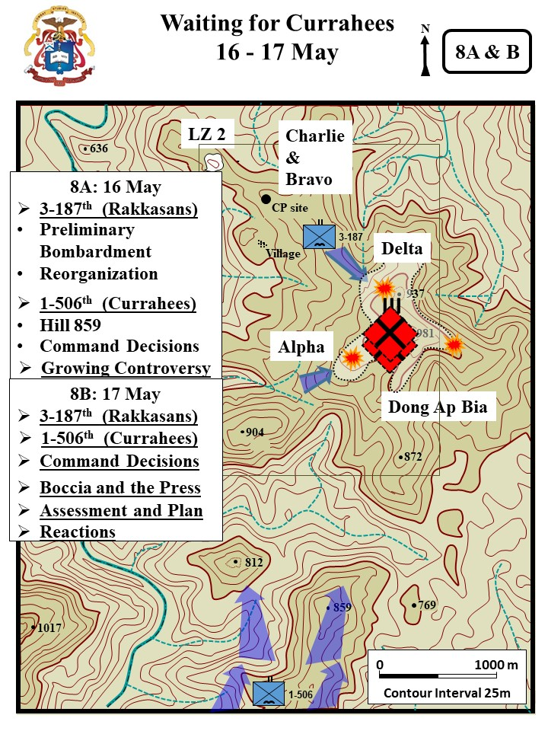

The two battalion coordinated attack on Hill 937 was rescheduled for 18 May. Plans were finalized during the day. Elements of the 3-187th were to move to the best position possible from which to support by fire the main attack by the 1-506th coming from the southwest. The attack was to be supported by a CS gas (tear gas) preparation in addition to a heavy tactical air and artillery preparation. Extra ammunition and other supplies were issued during the day. The pounding of the enemy positions by artillery and air continued throughout the day and night.

The 3-187th made final preparation for the attack on the following day. It was decided that the best way to support the attack by the l-506th was to simply move up the hill exerting maximum pressure on the enemy's defenses from the northwest. There was no significant enemy contact during the day.

Such was not the case with the l-506th which was continuing its movement toward Hill 937. They faced increasing resistance as they advanced. The enemy on the south side of the hill, as on the north side, was well dug-in and occupied concentric rows of mutually supporting bunkers which he defended with determination. The l-506th continued their advance, however, fighting from bunker to bunker in order to progress. To assist them, artillery, gunships and tactical air provided continuous support. CS gas (tear gas) was also used to dislodge the NVA from their bunkers. By nightfall the battalion was in position to launch the attack.

2-501st continued their search and destroy missions to the north, and west of FB Airborne encountering bunkers and equipment caches. Little contact was experienced during the 17th.

The 2/1 ARVN Battalion searching an area southwest of FB Bradley discovered four Russian trucks, five bulldozers, and 3,000 pounds of TNT, all which were destroyed.[14]

**18 May 1969**

**(Excerpt from XXIV Corps Historical Summary)**

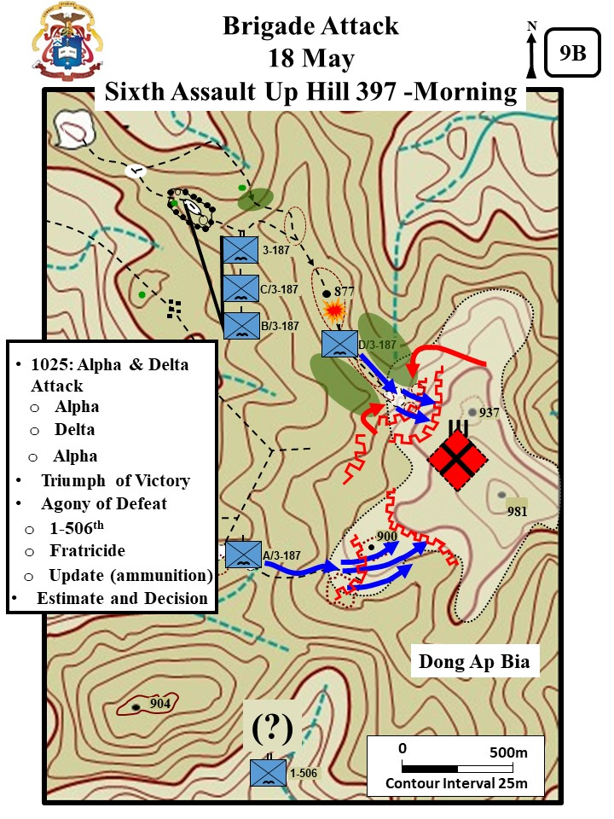

With both battalions believed to be in position to begin the attack, numerous airstrikes were again placed on the hill in an attempt to soften-up the enemy positions. By now, the once thickly covered hill was completely bald. Still, the enemy bunkers held. The airstrikes were followed immediately by an intensive artillery preparation and then the CS gas preparation which proved to be only marginally effective because of the weather conditions. The artillery continued to pound the hill as the two battalions moved out in the attack, the 3-187th with three companies from the north and the 1-506th with three companies from the south.

|  |
| --- |
| **The CS Attack**  The first volley missed the top of the hill and landed near Alpha 3-187. Most of Alpha’s gas mask had wet filters and they failed to work. Several men were caught in the gas and were momentarily incapacitated. The second CS volley landed on target. High winds quickly dispersed the gas. Specialist Philip Perron, a 20 year old riflemen in Charlie, remember, ***“They figured the NVA would all crawl out of their holes coughing and gagging… Anyway the wind shifted and the whole CS Gas theory didn’t work.”*** |
| Zaffiri, *Hamburger Hill*, 209-210, WPCFOR, Perron Interview |

The 3-187th was immediately engaged by a determined enemy force. The fire was intensive and withering but the companies were able to push on. The battalion commander was immediately overhead calling for artillery and mortar fire on the enemy positions and guiding his companies in the direction which appeared to have the best chance of success. As the companies inched up the hill, the enemy fire grew in intensity. The A Company attacked stalled against the 2d line of bunkers. D Company was particularly hard hit by automatic weapons fire, RPGs and claymore mines; casualties were heavy. Both A and D Companies were hit by mortars. A Company was being fired on from three directions.

|  |
| --- |
| **The Delta Company Fight**  Delta was particularly hard hit by automatic weapons fire, RPGs and claymore mines; casualties were heavy. CPT Sanders remembered, *“****We burst out of the wood line and the most instance fire I have ever seen…incredible, it was very intense.”*** Lieutenant Thomas Lipscomb’s 2d platoon was able to push through the first bunker line. Platoon members remembered the LT yelling: ***“Let’s go!” – “Move up!”*** and ***“Let’s get these bastards.”*** Lipscomb moved the unit forward using fire and maneuver. Men would rise up and dash forward a few meters and then go back to the prone position. The platoon had six men wounded by the time they moved into the 2d bunker line. For the first time, the Rakkasans observed enemy soldiers abandoning the forward positions and trying to retreat up the hill. Nevertheless, enemy resistance slowed the momentum of the attack. Lipscomb’s platoon charged forward against the trench line and an enemy grenade killed Lipsomp and wounded several other soldiers. CPT Sanders pushed LT Jerry Walden’s 1st Platoon forward to continue the attack. About 1200, CPT Sanders was seriously wounded. LT Walden continued the attack but was stalled when enemy counterattacks threatened his flanks. Walden moved up and down the line of 1st and 2d platoons urging the men forward. However, a NVA HMG blocked any advance. Walden tried to maneuver a squad against the MG, but several men were killed and wounded. PFC Michael Rocklen, a radioman, directed a successful airstrike against the HMG, but the company lacked the combat power to continue the attack (approximately 57 men remaining). |
| WPCFOH, Sanders Interview, Zaffiri, *Hamburger Hill*, 210- 215, Wright, Apache Snow, 18. . |

Even though gunships and artillery kept pounding the enemy positions, the NVA continued to place accurate fire on the attacking companies. C Company was dispatched to reinforce D Company and in trying to reach their position came under heavy fire and was pinned down for a short time; movement was extremely difficult. Meanwhile, A Company regrouped and continued the attack.

|  |
| --- |
| **Triumph of Victory**  On the BN right, CPT Harkins’ reenergized the Alpha advance after Lt. McGreevy was wounded. He pushed Lt Daniel Bresnahan’s 3d Plt to the front and soon reported that Alpha was into the 2d line of bunkers and less than 100 meters from the top of the hill. LTC Honeycutt believed he was finally on the verge of capturing the hill. |
| Zaffiri, *Hamburger Hill,* 215 – 216. |

It became increasingly difficult for the companies to move in face of the withering enemy fire so the attack was halted while the enemy was again hit with a concentrated mix of napalm and bomb strikes, gunships, mortars and artillery.

|  |
| --- |
| **Agony of Defeat**  Charlie moved up fast. However, when still 60 meters behind Delta they found that the enemy had re-occupied the first bunker line and temporarily halted their advance. LTC Honeycutt from a LOH personally directed mortar fire and directed the movement of Charlie to get them on the move again. Then CPT Harkins (Alpha) reported they were receiving heavy fire from the ridge on his flank. Honeycutt questioned the report, because that was the reported location of 1-506th. Brigade confirmed that 1-506th was just northeast of Hill 904 (also referred to as Hill 916). Harkins confirmed he was taking fire from that location. Honeycutt flying with ***“Crazy Rairdon”*** took the LOH to Hill 904 and requested that 1-506th mark their lead element with smoke. The smoke confirmed that 1-506th was still well to the south and not in position to support 3-187th’s attack against Dong Ap Bia. Honeycutt recognize that Alpha and Delta were in what he called ***“eye ball to eye ball contact”*** and if he tried to pullback the enemy would counterattack. Additionally his companies were almost out of ammunition. Pfc Michael Smith (Delta) typified the ammunition situation in both Delta and Alpha. Smith was a M79 gunner who started the fight with 79 rounds of 40mm grenades. He fired those in less than an hour. He then picked up an M16 from the wounded soldier and fired off 40 magazines. The M16 overheated and jammed. He then picked up another M16 and fired another 30 magazines. In time, he was on his fifth M16. Pfc Donald Harris (Alpha) remembered, ***“I probably shot 500, 600 round… My M16 was too hot to hold on too. We were starting to run out of ammunition.”*** Bravo Company sent a platoon forward with an ammunition resupply. Unfortunately the platoon was hit by Cobra gunships killing 1 and wounding 4. |
| Zaffiri, *Hamburger Hill,* 217 – 219. |

The attack resumed and the determined companies were almost on top of the hill when they were repulsed by a determined enemy who blew claymore mines and grenades in the midst of their own positions

|  |
| --- |
| **Lieutenant Joel Trautman’s Attack**  CPT Johnson (C Company) moved forward and consolidated their remnants of Delta with his company. Johnson believed the enemy resistance was too strong and that any attack was suicidal. However, LTC Honeycutt insisted that the company attack. LT Trautman (1st Plt, Charlie) tasked Sergeant Tom Valetine, his best squad leader, to lead the attack. Valetine called for the five men near him to follow and all refused. Trautman intervened and told the men they had to go. Again they all refused. Lt Trautman told the men, ***“Look…, if I go with you, will you go?”*** One of the five stated, ***“If you’ll lead us, I’ll go.”*** And all the others agreed. Trautman remembered, ***“I picked up my weapon and walked though my men and said, ‘come on let’s go.’ I didn’t know if they were going to follow me or not, but they did.”*** Trautman led the charge up the hill at a run, jumping into bomb craters, and then running forward again. All five men followed him. They made it about 30 meters up the hill until one of the men was hit. The men stop in a bomb crater to care for the wounded man. Trautman was several meters to the front yelling for the men to follow when he was hit in the left leg. The other four men had returned to the platoon’s start line carrying their wounded buddy. Trautman slipping in and out of consciousness was isolated and alone. He remembered, ***“I was up there for [maybe] 2 hours… I thought I was going to die there.”*** Fortunately, a sergeant led a fire team to rescue the Lt and pulled him back into the friendly lines. |
| Zaffiri, *Hamburger Hill*, 221; WPCFOH, Trautman interview. |

|  |
| --- |
| **LTC Honeycutt’s Foray**  LTC Honeycutt, who was flying overhead, decided to personally intervene to get the attack moving again. He returned to the battalion CP and collected Major Collier (S3) and his three RTO’s to move forward and join the attack. It took 30 mins to cover the 600 yards to the old Bravo LZ which he found filled with wounded. He briefly talked with the wounded and confirmed that the LZ had good security. Honeycutt then moved forward again. About 100 meters past the LZ they were ambushed. A grenade explosion knocked Maj Collier down and stunned him. However, Honeycutt and the 3 RTOs returned fire and killed six to seven NVA coming up out of the draw. Maj Collier then joined in the fight and the five Americans charged into the draw engaging approximately 10 NVA soldiers. Honeycutt sent one of the RTO’s back down to the old Bravo LZ to warn them that NVA were in the area. He then continued forward to Charlie’s position. |
| (Zaffiri, *Hamburger Hill*, 223-225. |

At about the same time a torrential rain fell turning the slopes of the bald hill into a virtual mud slide. It was impossible for the soldiers to keep their footing and they kept sliding back down the hill.

|  |
| --- |
| **Torrential Rain Fall**  Lt Boccia remembered,***“This wasn’t rain: It was as if the sky opened up and dropped the Red Seas our heads… The water, tons of it, penetrated the loosened soil, turning it quickly into a liquid, slurry-like wave. Gravity took care of the rest. Men were literally washed down the slopes, absolutely powerless to stop their descent.”*** |
| Boccia*, The Crouching Beast*, x. |

With casualties beginning to mount, the heavy rain falling, and considering that the l-506th was having an equally hard time progressing up the other side of the hill, the brigade commander directed the companies to pull back so as to avoid taking any unnecessary casualties. During the day, 3-187th had 14 men killed in action and 64 wounded while killing an estimated 112 of the enemy.

The l-506th had initiated their attack immediately following the artillery and air preparation and like the 3-187th came under intensive fire. Enemy mortars fired on the companies throughout the day. Movement had to be slow and deliberate fighting from bunker to bunker. By nightfall, the battalion had progressed to within approximately 600 meters of the crest of the hill where they established their night defensive position.

MG Melvin Zais, the division commander, followed every minute of the action, as he had been doing since 10 May. In order to have a clear and complete picture of what was happening, he spent most of every day either overhead following the action from his helicopter or on the ground talking with the troopers and their leaders getting a first-hand view of the tactical situation and the hardships facing the soldiers and, on occasion, was subjected to enemy fire. At this point in the battle at Dong Ap Bia, the Division Commander had a choice of either turning his back on the entire operation or pressing on. After carefully reviewing the situation, General Zais decided to reinforce the 3-187th and l-506th with two additional battalions in order to completely surround the hill. General Zais discussed his decision with MG Troung, CG, 1st ARVN Division, who eagerly made available the 2/3 ARVN Battalion for employment as one of the reinforcing battalions. The 2-501st, which had been operating just to the east of the A Shau Valley was designated to be the second reinforcing battalion. During the night, plans were developed for a four battalion coordinated attack on the morning of 20 May.

|  |
| --- |
| **Reinforcements, Command Decisions, and Decisions Reconsidered**  LTC Honeycutt requested that brigade reinforce him with units, either a company or several platoons. He believed his shot up companies no longer had the command structure needed to integrate individual replacements. Initially, brigade agreed to the request and stated they would move in company immediately to reinforce the 3-187th. However, MG Zais intervened and decided instead to send 2-506th to do a relief in place with 3-187th. LTC Honeycutt found out about the decision when LTC Gene Sherron (commander 2-506th) arrived at the 3-187th CP to discuss the relief. Soon after that, MG Zais arrived at the 3-187th CP. LTC Honeycutt convinced Zais that 3-187th deserved the opportunity to remain in the fight. Honeycutt also negotiated the attachment of Alpha of 2-506th to his depleted battalion. |
| Zaffiri, *Hamburger Hill*, 219-220, 230-232. |

**19 May 1969**

**(Excerpt from XXIV Corps Historical Summary)**

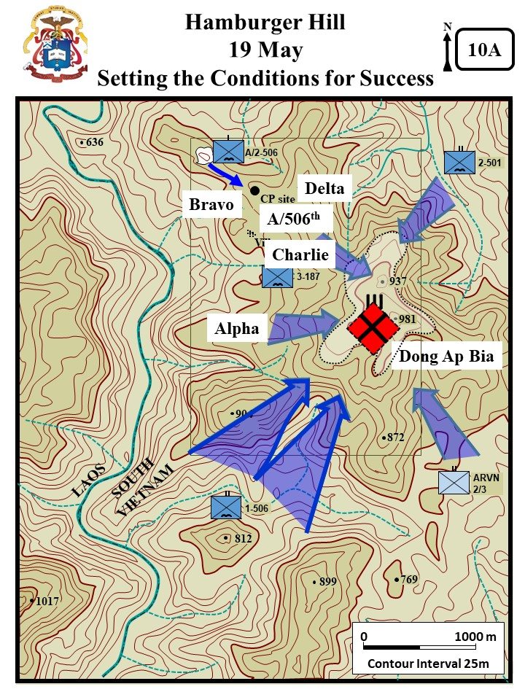

This day was devoted primarily to preparation for the attack on the morning of 20 May. The 2/3 ARVN Battalion was moved from Hue and combat assaulted into a landing zone approximately 1200 meters east-southeast of Hill 937. The 2-501st was combat assaulted into a position 1200 meters northeast of the hill. The landings of both battalions were unopposed and they immediately moved out up the ridges to establish their attack positions for the following day.

The 3-187th, which had been reinforced with one company from the 2-506th, developed plans for the attack and resupplied the companies. The battalion commander spent a good part of the day over Hill 937 directing air, artillery, and mortars against the enemy positions. A relentless pounding of the hill was continued throughout the day and night. By nightfall, everything was in readiness for the attack.

The l-506th continued to push up the hill during the day in order to be in a better attack position by nightfall. The enemy resistance, as on previous days, was determined. The bunker to bunker fighting continued. By dark, the companies were within 200 meters of the top of the hill.

|  |
| --- |
| **The Brigade Plan**  That evening the Brigade S-3 (Maj Montgomery) flew into the 3-187 area to brief the plan. He told LTC Honeycutt that the Rakkasans were to be a fixing force. They were to advance till in contact to hold the enemy in place while the other battalions took the hill. LTC Honeycutt voiced his disapproval of the plan. ***“I don’t like it… Because we ain’t goin’ through that fix-the-enemy-in-place routine again. The next time we get to the top of that mountain, we’re gonna take the sonofabitch. If the 506th gets there, that’s fine. And if the 2/501st gets there, it’ll be great. And if the ARVN get there, I’ll be F—n thrilled. But we ain’t goona sit here like [before] and get our asses shot off waiting for them.”*** Brigade agreed to let 3-187 push to the top of the hill.  **Honeycutt’s Plan**  LTC Honeycutt took all the company commanders into the air for a commander’s recon. They then returned to the battalion CP to review the plan. Charlie was the main effort and would attack along the main ridge, through the clearing, and up the hill. Alpha parallel to Charlie up the southern spur again. A/2-506th was to initially follow Charlie, but then at the clearing they were to swing to the left to protect Charlie’s left flank. Delta was positioned behind A/2-506th as the battalion reserve. Bravo was responsible for securing the battalion CP and on-order was to bring forward ammunition. |
| Zaffiri, *Hamburger Hill*, 242-244. |

**20 May 1969**

**(Excerpt from MG Wright, *Apache Snow*, 20-23)**

Late in the morning of 20 May, following an artillery preparation, the four battalions executed a coordinated assault against Dong Ap Bia.

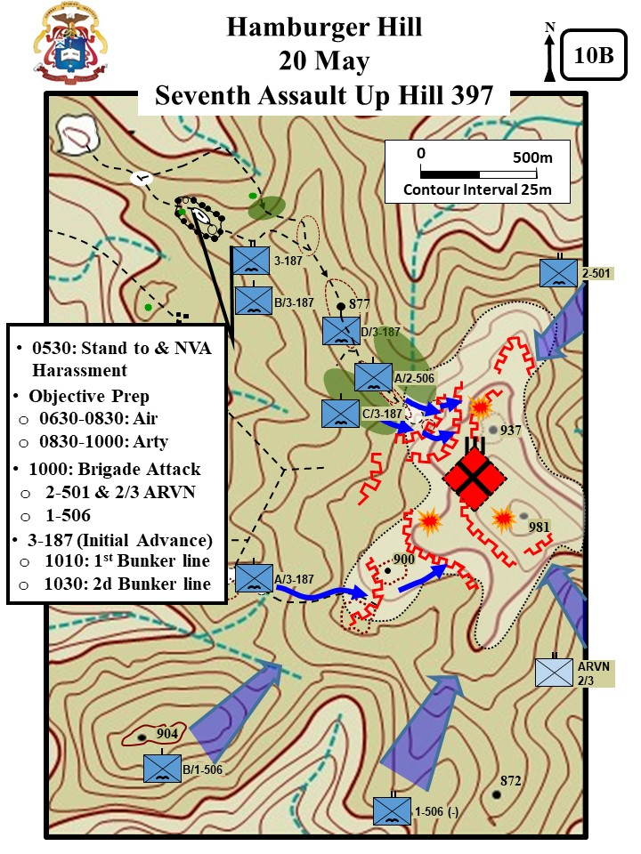

**3-187th:** The Rakkasans with A Company on the right, C Company in the center and attached A Company, 2-506th on the left, moved southeast for a coordinated attack on the Hill when they received concentrated RPG and small arms fire. The attacking elements returned the fire with organic weapons and continued to fire and maneuver up the hill.

|  |
| --- |
| **Charlie’s Fight**  In the west, the Rakkasans initial maneuvers were unopposed. When the battalion came near the top of the hill, the enemy opened fire. At approximately 1040, 10 to 15 NVA rose up from a trench along the 2d bunker line and opposed Charlie with RPGs and at least 7 in Charlie were wounded. Charlie returned fire and the NVA rolled grenades down the hill and wounded 4 more in Charlie. At 1145, the fight for 2d bunker line still ongoing, and Charlie brought forward 90mm RR to fight the bunkers. About 1200, Lt Donald Sullivan’s 2d Platoon passed through the bunkers and seized the top of the hill. LTC Honeycutt was immediately above the battle piloting an OH-6 observation helicopter (Rairdon had been wounded two days earlier). Charlie had seized a few bunkers on the top of the hill. However, they were alone with dug-in enemy to the right and left, and amongst them. Honeycutt was worried that an enemy counter-attack might push Charlie off the hill.  **Alpha’s Charge**  Alpha was still fighting to get into through the second bunker line. They had one platoon leader and 15 men wounded so far. The company attack stalled when CPT Harkins was seriously wounded. A bullet passed through his left ear and then the neck to lodge in his back. He lost most of his hearing and sight from his left eye. Honeycutt told him, **“*If you can’t fight the company, then turn it over to someone who can.”***At about 1215, Harkins directed his radio man to advance and pull him up the hill while he held onto the radio to maintain his balance. Nevertheless, heavy enemy fire and rolling grenades down the hill again stalled the Alpha advance. At the same time a NVA squad counter-attacked into Charlie’s right flank. Nevertheless, individual sergeants and soldiers within Alpha reenergize the Alpha Attack. SP 4 Johnny Jackson, a M60 gunner, yelled ***“F__ this bullshit”*** and dashed forward ***“wildly spraying bullets from side to side.”*** At about 1230, he seized a crater at the top of hill. Soon after that he was wounded by a white phosphorous marking rocket. Nevertheless, he secured Alpha’s south flank and held his position (he was awarded the Silver Star for his actions). SP 4 Michael Vallone watched Jackson’s charge and yelled, ***“Follow-Me… Come on, everybody, follow me!”*** All of Alpha then surged forward and seized the top of hill. Captain Harkin’s also charged up the hill with his radio man holding him up and guiding the way. At the top of the hill, Harkins organized a defensive perimeter and tied in with Charlie. He then collapsed. Lt Goridie Atchenson took command of the company.  **A/2-506th’s Attack**  About the same time that Alpha surged to the top, A/2-506 also seized the north portion of the hilltop and secured Charlie’s north flank. |
| Zaffiri, *Hamburger Hill*, 124, 264-265); Boccia, *The Crouching Beast*, 448. |

As the elements approached the crest they again came under heavy small arms fire from the west and RPG and small arms fire from the south. 3-187th returned the fire with organic weapons and employed artillery, ARA, and gunship on the suspected enemy locations and continued with A Company, 3-187 reaching the top of Hill 937 first at 1145H. The attacking force received additional fire as the enemy attempted to cover its withdrawal to the southwest into the 1-506th locations. The elements continued to return small arms fire and employed ARA, artillery, and gunships on the retreating enemy. The contact terminated at 1600H and a sweep of the area revealed seventy eight NVA killed and one prisoner of war. Throughout the day, 3-187th company commanders noted the noise level was so great that could not ascertain if friendly artillery was being employed, the crack of small arms fire drowned out any other sounds. The inability to use radios due to the noise level made it imperative that messengers be used to relay messages and directions to the forward elements. In addition various colored smoke grenades were detonated by the NVA making it extremely difficult to place effective air strikes on the desired targets, and to control friendly fires. 20-21

|  |
| --- |
| **Clearing the Hill**  The two Alphas and Charlie had to beat off several counter-attacks. One of the lynch-pins of the defense was SP4 Jackson, suffering with the white phosphorous wound, but still in the fight. Witness’s stated he ***“seemed to be enjoying the payback”*** *o*f the NVA attacking his position. The Rakkasans started clearing the top of the last enemy resistance while the other BNs held blocking positions. A burial trench with over a hundred bodies was discovered. The Rakkasans discovered that the mountain was honeycombed with tunnels. In one tunnel they discovered a room with 40 dead NVA stacked liked cord wood. They also found a functional hospital and a storage room with 75,000 rounds of ammunition, thousands of mortar ammunition and RPGs, and over 10 tons of rice. |
| (Zaffiri, *Hamburger Hill*, 263, 270-272. |

**1-506th:** At 1055H, A and C Companies, 1-506th moved north to assault the hill and encountered heavy enemy resistance. Elements continued to receive small arms, RPG, and mortar fire from the same location throughout the day. The companies involved returned small arms fire and employed ARA, artillery and gunships for support on suspected enemy locations. Contact terminated at approximately 1600H, but the attacking elements continued to receive sporadic fire throughout the night. A sweep of the area revealed eight NVA killed. B Company, 1-506th continued to attack the hill form its potions on the left of A and C, and encountered heavy resistance while moving north toward the hill. To counter the enemy small arms, RPG, and mortar fire they employed air support on the suspected enemy locations with B Company being between the enemy and the Laotian Border.

**2-501st:** A, B, and C Companies of the 2-501st, while moving southwest up Hill 937 encountered no enemy resistance. As the elements continued to move they discovered numerous huts and bunker complexes vacated by the retreating enemy.

**2/3 ARVN Battalion:** At 0715H the 2/3 ARVN Battalion while moving northeast for the coordinated attack on Hill 937 encountered light enemy resistance and discovered moderate sized caches of assorted ammunition, in addition to a six foot wide road with a power cable which they followed to their objective. Continuing to advance toward the top of the hill they received concentrated small arms fire and employed air and artillery support to destroy the enemy location. Contact terminated at approximately 1600H and a sweep of the area was made revealing six NVA bodies and three AK-47’s.

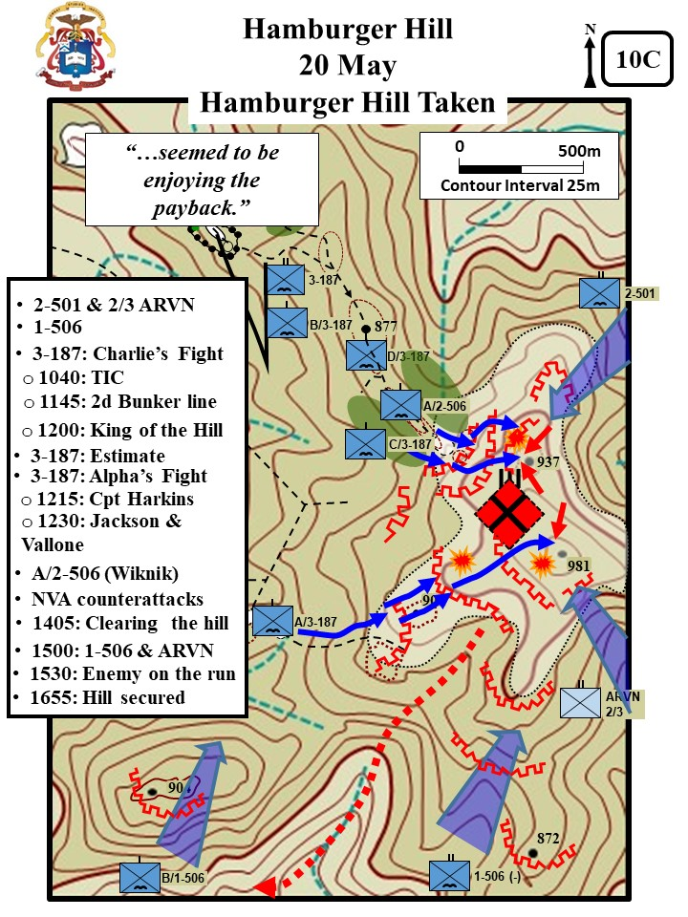

**Aftermath**

**(Excerpt from CMH PUB 76 -6, 38-41)**

After ten days of fighting, Ap Bia Mountain was in American hands. More importantly from the division’s perspective, it had decimated the enemy. The official body count was 633 North Vietnamese dead, while the Americans lost 70 dead and 372 wounded.

|  |
| --- |
| **3-187th Infantry (the Rakkasans )**  36 Killed in Action  255 Wounded in Action and Evacuated  50 Wounded in Action and Returned to Duty  2 Missing in Action  30% (102 men) were from fratricide incidents. |
| Headquarter 101st Airborne Division, Fact Sheet, Summary of Operations, 24 May 1969 |

General Zais was pleased with the results, although he regretted the cost in American lives. In the end, it was the enemy he was after, not the terrain. ***“The 29th North Vietnamese Army Regiment had been eliminated***  ***as a force to contend with at a later date,”*** read one report.

But if MACV and the 101st Airborne Division were satisfied, others were dismayed. While the battle was not much different than countless other fights, circumstances made the engagement a volatile one. The Nixon administration had come into office promising peace, and to many people that meant avoiding bloody fights with the enemy. The spark that touched off the tinder was an Associated Press story by journalist Jay Sharbutt, who wrote of reluctant soldiers pushed onward by unrelenting officers. Senator Edward M. Kennedy used the story to denounce President Nixon’s Vietnam policy as being ***“counter to our stated goals and intentions in Paris***.” He also condemned the Army’s tactics, saying it was ***“senseless and irresponsible to continue to send our young men to their deaths to capture hills and positions that have no relation to ending the conflict.***”

|  |
| --- |
| **Jay Sharbutt**  *Paratroopers came down from the mountain, their shirts dark green with sweat, their weapons gone, their bandages stained brown and red from mud and blood. Many cursed their hard-nosed Battalion commander, LTC Honeycutt, who sent three companies Sunday to take the 3,000 ft mountain just over a mile east of Laos and overlooking shell pocketed A Shau Valley. They failed and suffered. “That damn black jack won't stop until he kills every one of us" said one of the 40-50 Abn Div troopers wounded.* |
| Headquarter 101st Airborne Division, Fact Sheet, Summary of Operations, 24 May 1969 |

General Zais was stunned. “***These people are acting like this was a catastrophe for the U.S. troops,”*** he told his officers. ***“This was a tremendous, gallant victory.”*** Defending the operation, the commander of the 101st, MG. Zais, acknowledged that the hill’s only significance was that the enemy occupied it. “***My mission,”*** he said, ***“was to destroy enemy forces and installations. We found the enemy on Hill 937, and that is where we fought them.”[15]*** But he was fighting a losing battle. Operations aimed at destroying the effectiveness of enemy units by killing as many soldiers as possible—a war of attrition—were no longer credible in the eyes of many Americans. The public was tired of seeing body bags. Abrams, who had rejected calls the previous year to reduce U.S. casualties, could no longer defy the mounting pressure. From now on, he and his subordinates would have to exercise greater restraint in undertaking actions that put Americans in harm’s way. He nevertheless recognized Zais’ achievements by promoting him to become the commander of XXIV Corps.

About one month later the 101st Airborne Division left the A Shau Valley, and the North Vietnamese were free to use it again. American plans to return in the summer of 1970 came to nothing when enemy pressure forced the abandonment of two firebases needed for operations there. The loss of Firebase O’REILLY, only eleven miles from Hue, was an ominous sign that enemy forces had reoccupied the A Shau and were seeking to dominate the valleys leading to the coastal plain. Until redeployed in 1971, the 101st Airborne Division devoted most of its efforts to protecting Hue.[16]

The new approach was not long in coming. On 14 May, three days into the battle for Hill 937, President Nixon told the American people, ***“We have ruled out attempting to impose a purely military solution on the battlefield. We have also ruled out either a one-sided withdrawal from Vietnam, or the acceptance in Paris of terms that would amount to a disguised defeat.”*** Part of his plan was for a phased withdrawal of all U.S. and North Vietnamese combatants. To get the ball rolling. , Nixon would take the first step, withdrawing some U.S. forces before North Vietnam agreed to remove any of its troops. In the coming year, Nixon withdrew 139,000 of the 335,790 troops in Vietnam. By 1972, the in-country strength was down to 24,200 and the United States was fully committed to the Vietnamization of the War.

**Annex A: 3-187th Airborne Infantry Battalion/Company/Platoon (The Rakkasans).** Details from Gordon Rottman, The *US Army in the Vietnam War 1965-73 and other various sources.*

**The 101st Airborne Division Organization**

**The 101st Airborne Division:** In 1968, the 101st Airborne Division was taken off jump status and converted to an airmobile division. The division was designated the **101st Airborne Division (Airmobile).** The three infantry brigades (1st -3rd Brigades) were the largest maneuver elements of the division.

**The infantry battalion** was the largest maneuver element of the Airborne Infantry Brigade. Commanded by a lieutenant colonel, the infantry battalion was composed of a headquarters and Headquarters Company, and four rifle companies. In 1969, the authorized strength, with four rifle companies, was about 800 men using a modified Infantry Battalion (light) organization. Even within the same brigade, battalions and companies reorganized their assets differently.

In 1967, the **Airborne Infantry Battalion Headquarters** deployed from the states with an authorized strength of 252. However, this was significantly trimmed down by 1969 with in-country changes to the TO&E to provide the battalion’s 4th rifle company. At the Battle of Dong Ap Bia, the 3-187th battalion headquarters consisted of the CO, sergeant major, staff officers and their staff personnel. Additionally there were elements of the communications, support (service), medical platoon, and mortar platoon (4x 81mm). The records make no mention of a scout/reconnaissance or anti-tank platoon. Most likely the scout platoon had been reorganized as a standard rifle platoon in the battalion’s 4th company (Delta). The anti-tank platoon personnel may have been guarding the battalion’s home firebase or have been reassigned within the battalion as riflemen. The battalion XO (executive officer) and numerous other personnel remained at the home firebase to conduct administration and push supplies forward. At the Battle of Dong Ap Bia many of the rear area personnel were brought forward and reassigned as riflemen during the course of the battle.

The **Company Headquarters** consisted of 13 men. Only a few of these deployed to the field. Usually the field headquarters consisted of the CO, first sergeant, a couple of radio operators, and attached medics. As with the battalion, the XO remained in the rear with most of the headquarters personnel to conduct company administration and push forward supplies.

The company had 3 to 4 **Rifle Platoons**. B Company, 3-187th initially maneuvered with 4 rifle platoons. The other companies (A, C, & D) appear to have maneuvered with only 3 rifle platoons. The rifle platoons were similarly armed and organized. The platoon headquarters had a platoon leader, platoon sergeant, and an RTO. The three ten man rifled squads consisted of a squad leader and two fire teams. The 11-man weapons squad had leader, two machine gunners (M60 GPMG) and assistants, two anti-tank gunners (90mm RR) and assistants, and two ammunition bearers. The platoons were rarely up to strength because of soldiers off sick or on leave. The squads usually deployed with eight men or less. The weapons squad was usually disbanded and the M60 GPMG teams attached directly to the squads. Veteran units usually acquired a third M60 GPMG for the third squad.

The rifle companies had an authorized strength of 164 men. Lieutenant Frank Boccia in his story of the battle, *The Crouch Beast*, states that Bravo air assaulted into the fight with 107 men. The rifle platoons authorized strength was 44 men. Boccia states that his platoon entered the fight with only 34 men.

**3-187th Infantry Order of Battle**

**Alpha:** Captain Gerald Harkins

1st Plt: Daniel Bresnahan

2d Plt: Lt. Frank McGreevy

3d Plt:Gorde Atcheson

**Bravo:** Captain Charles Littnan then Captain Chappel

1st Plt: Frank Boccia

2d Plt: Marshall Eward

3d Plt: SFC Louis Garza then Lt Lou Charles

4th Plt: Chuck Denholm

**Charlie:** Captain Dean Johnson

1st Plt: Joel Trautman

2d Plt: Donald Sullivan

3d Plt: James Goff

**Delta:** Cpt Luther Sanders

1st Plt: Jerry Walden

2d Plt: Thomas Lipscomb

3d Plt: Mattioli

**A/2-506th:** Captain Bill Womble

1st Plt: Len Maher

2d Plt: ____

3d Plt: ____

**3-187th Weapons**

**M16 Rifle:** In 1969, the M16 rifle was the standard firearm for the infantryman. The weapon weighted on 6.3 pounds and its caliber is 5.56mm (about .22 inches). The weapon used a 20 round magazine.

**M-60 Machinegun:** It was the standard light machinegun used in Vietnam. It weighed 23.05 pounds. Because of its weight and bulk it was commonly referred to as **“the Pig.”** Its caliber was 7.62. The ammunition was extremely powerful and it could chew up and pass through substantial cover. The ammunition usually comes in 100-round belts and it can be fired semi-automatically or automatically. Although it could be fired from the hip at close ranges, the powerful recoil was difficult to control and it was best fired from a prone position using the attached bipod. Each rifle squad normally had one M-60 machinegun.

**M-79 Grenade Launcher:** The M-79 was many times referred to as “the blooper.” The weapon provided the means of delivering grenades accurately at much greater range than they could be thrown. It weighs 6.45 pounds, its caliber is 40mm and the ammunition consists of self-propelled explosive grenades that loaded individually between shots. It was very accurate, deadly and reliable. Each fire team was authorized one M-79. However, the understrength squads in Vietnam normally did away with the fire team organization and only had one M-79 per squad.

**M-67 90mm Recoilless Rifle:** The M-67 was similar in appearance to the famous bazooka of WWII and the Korean War. It was designed as an anti-tank weapon. However, in the Vietnam War it was primarily used against enemy personnel and enemy fortifications. It was very effective against enemy bunkers. However, its weight (37.5 lbs) and size (53”) made it an unpopular weapon. Most general histories of the Vietnam War say that the 90mm Recoilless Rifle was rarely deployed to the field. However, at Hamburger Hill there are numerous references to its use in the battle.

**Appendix B: Tactical Air and Artillery Fire Support (Excerpt from XXIV Corps Historical Summary)**

At the battle at Dong Ap Bia, artillery and/or tactical air bombardment of Hill 937 and its ridges was continuous, day and night, throughout the operation. During daylight hours, there was seldom a time when tactical fighters were not orbiting overhead ready to respond to the ground commander's request. During hours of darkness radar controlled bomb drops (Skyspots) were placed on the hill. When airstrikes were not hitting the hill, the fires of eight different artillery batteries plus the aerial rocket artillery battalion were pounding the enemy positions and supporting the maneuver elements. The fire support provided the attacking forces can only be described as totally responsive. Without this excellent support, the number of friendly casualties would undoubtedly have been much higher. Following is a summary of the nearly 3.5 million pounds of bombs dropped and artillery fired at enemy positions on and around Dong Ap Bia during the period 10-22 May.

|  |  |
| --- | --- |
| **TACTICAL AIR SUPPORT** | |
| Bombs | 1,088.5 tons |
| Napalm | 142.5 tons |
| 20 MM | 31,000 rounds |

|  |  |  |  |  |  |
| --- | --- | --- | --- | --- | --- |
| **ARTILLERY (Number of Rounds)** | | | | | |
|  | High Explosive | White Phosphorus | HC | CS Tear Gas | Total |
| 105 MM | 10,634 | 517 | 69 | 256 | 11,474 |
| 155 MM | 3,919 | 94 | 17 | 0 | 4,030 |
| 8” | 834 | 0 | 0 | 0 | 834 |
| 175 MM | 253 | 0 | 0 | 0 | 253 |
| 2.75” Rocket | 2,622 | 0 | 0 | 0 | 2,622 |
| Total | 18,262 | 611 | 86 | 256 | 19,213* |
| *Equals 513 tons | | | | | |

The following artillery units supported the action at Dong Ap Bia:

* A/2-319 Artillery (105)
* B/2-319 Artillery (105)
* C/2-319 Artillery (105)
* B/2-11 Artillery (155)
* C/2-11 Artillery (155)
* A/12 Artillery (ARVN) (105)
* A/1-83 Artillery (8")
* C/l-83 Artillery (175)
* 4-77 Artillery (ARA)

**Appendix C: 4-77th Artillery (Aerial Rocket Artillery). Excerpt from CMH Pub 90-4, VIETNAM STUDIES AIRMOBILITY 1961-1971 (121-122, 276)**

The U.S. infantryman over the years has come to expect and get continuous artillery support on call. The artilleryman in turn has depended on the infantry to secure his positions and keep his supply routes open. In Vietnam no simple solutions were available to continue this long-established teamwork. The early designers of the airmobile division had recognized that they would have to sacrifice the heavy 155mm howitzers and be content with moving the 105-mm howitzer with the Chinook helicopter. The Little John rocket had been included in the original organization, but when the 1st Cavalry deployed to Vietnam (1965), the Little John was deleted due to tactical and manpower considerations. To make up for this deficiency in firepower, an **aerial artillery battalion** was organized as the general support artillery (2-20h Artillery ARA).

|  |
| --- |
| In 1967, the 4-77th Artillery (ARA) deployed with the 101st Airborne Division. |

While there were other U.S. Army aviation units with an attack mission in the airmobile division, the ARA was unique because it was controlled by division artillery and not the [Vietnam- era] aviation group. This allowed the artillery commander to coordinate the ARA with other fire support missions (tube artillery and air strikes). In the [Vietnam-era] airmobile division, there were also attack helicopters in the cavalry squadrons and standard lift battalions. Each lift battalion had 12 gunships in their Company D.

The ARA battalion was the most concentrated and centralized element of attack aviation in the [Vietnam-era] airmobile division. Each ARA battalion consisted of one H&HB (Headquarters & Headquarters Battery) and three firing batteries (Alpha, Bravo and Charlie). A firing battery was equipped with 12 attack helicopters.

|  |
| --- |
| The 101st Airborne Division’s 4-77 Artillery (ARA) was equipped with the AH-1G Huey Cobra. |

The ARA battery perform the same type of fire support missions conducted by conventional artillery. Its range was only limited by the helicopter's combat radius and greatly exceeded the range of the division’s 105mm tube artillery. The missions included support of ground troops, LZ preparatory fires, interdiction, and counter-battery fire. In addition to standard artillery missions, the ARA helicopters were also employed as escorts for medevac and re-supply helicopters. ARA Cobras also teamed with light observation helicopters to perform tactical reconnaissance. The tactical reconnaissance mission was usually performed by the airmobile division's air cavalry squadron.

|  |
| --- |
| AH-IG HUEY COBRA |
| **Mission:** Enroute escort, reconnaissance, and direct fire support; **First delivery:** 1967; **Rotor diameter:** 44'; **Length:** 52' 11 ½”; **Basic weight**: 5,783 lbs; **Payload:** 1,993 lbs; **Crew:** 2; **Passengers:** 0; **Cruise airspeed:** 130k; **Maximum airspeed:** 190k; **Armament:** 40·mm grenade launcher, minigun, 2.75" rockets, and guided missiles. |
| **2.75” Folding Fin Aerial Rocket**  The primary weapon of the ARA units was the 2.75” Folding Fin Aerial Rocket (FFAR). The early gunships (UH-1C) could carry 48 rockets in two racks of 24 each. The Cobra was faster and more powerful. It could carry 76 rockets. |

From the artillery viewpoint, the most significant development of the first year's operation of the 1st Cavalry Division was that aerial artillery came of age. In the beginning, some officers considered aerial rocket artillery to be a nuisance on the battlefield, and they could not understand why its method of employment should be any different than the armed helicopter which escorted the tactical troop lift. Fortunately, the aggressive spirit of the aerial rocket artillery battery demonstrated that it could and should be used in mass. While the other armed helicopters were preoccupied by pinpoint targets, the aerial rocket artillery could deliver area fire with the same responsiveness (and through the same communication channels) that tube artillery had done in the past. These same aerial rocket artillery assets, if distributed piecemeal throughout the division, could not have functioned nearly as well. In this case, the whole was greater than the sum of all its parts. Aerial rocket artillery never entirely replaced tube artillery, nor was it ever meant to. However, by careful allocation of fire and precise timing of ships on station, the aerial rocket artillery was able to provide a remarkable volume of fire at times when no other fire support was available.

|  |
| --- |
| A significant disadvantage of ARA units was the difficulty conducting missions during bad weather or at night. Tube artillery could fire in any conditions (bad weather, day, or night). The ARA battalion was intended to replace the 155mm of the standard division artillery. However, both the 1st Cavalry Division and the 101st Airborne Division found they still needed the heavy 155mm artillery, and each received an attached 155mm battery. |

To their credit, the aerial rocket artillery developed the same combined arms partnership with the infantryman that has always existed between the red leg and the dog soldier. To the infantryman who has never been in an airmobile division, it is a very difficult thing to explain the responsiveness and effectiveness of aerial rocket artillery. Aerial rocket artillery, in contrast to the roving gunship, generally stayed on the ground with one section having a two-minute alert time. They were positioned so to be only a matter of minutes away from any potential target. Two minutes after a fire mission was received they were airborne, and, in a matter of a few minutes more, on target. As soon as the first section departed, a second section moved from a five-minute alert to the two-minute alert status, and another standby team moved to the five-minute alert. By this method, continuous and accurate firepower could be delivered. Aerial rocket artillery was so effective in the 1st Cavalry Division that the artillery commanders had to constantly remind the Infantry to use tube artillery when appropriate rather than call automatically for aerial rocket artillery support.

The ARA concept disappeared from Army aviation by the mid-1970s and was replaced by more generic attack aviation units.

**Appendix D: The 29th Regiment (North Vietnamese Army). Excerpts from the Information from the Defense Intelligence Agency, Southeast Asia Military Fact Book, January 1968 and Tactical and Material Innovations (CMH Pub 90-21-1)**

“…one of the best infantry combat forces in the world, capable of incredible feats of endurance and raw courage even against vastly superior firepower and under the worst of physical conditions.”[17]

**Overview**

The People’s Army of Vietnam (PAVN), referred to by the US Military as the North Vietnamese Army (NVA) was a formidable force. The NVA divisional formations were tailored specifically for operations in South Vietnam. These divisions were highly foot-mobile and flexible in force structure, organization, and strength. Normally these light infantry divisions were composed of two to four infantry regiments and a varying number of technical and fire support elements. They lack wheeled transport and the type artillery normally associated with a conventional division.

The regiments were organized and trained as conventional light infantry. As a light infantry force, the NVA compensated for its weakness in firepower with “rigorous discipline, tactical superiority, and careful preparation.”[18] They adapted their tactics to the terrain and in order to match the firepower and mobility of the Free World Forces.[19]

The regiment’s personnel were combat-trained, and inured to physical hardship. They were masters in concealment, camouflage, and in their ability to dig-in and fortify their positions. The leadership was dedicated and capable. The combat units were cohesive and disciplined. Morale and loyalty were high and constantly assured through tight party control. The principal limitations of the soldiers were deficiencies in advanced weapons and heavy equipment skills, a low level of education, and a lack of technical skills.

**Organization:**

The **29th NVA Regiment** was called “The Pride of Ho Chi Minh,” and considered one of the best regiments in the North Vietnamese Army.[20] The Regiment consisted of a headquarters and three battalions (7th, 8th, and 9th Battalions)[21]. The regimental HQ had several supporting companies:

* **Mortar Company** was equipped with six Type 53 82mm mortars. It was a Chinese copy of the Soviet 82-BM-37 Battalion Mortar. The location of the NVA mortars during the fight are not known. However, the records show that on numerous occasions the US soldiers reported receiving mortar fire.*
* **Anti-Air Company** was equipped with up to 18 Type 54 12.7mm AA DShKM (HMG). The records are not specific on the number of HMGs present at Hamburger Hill. However, both ground and air elements did report receiving HMG fire.*
* **Recoilless Gun Company** was equipped with six Type 52 75mm recoilless guns. The records make no specific mention of NVA recoilless guns being fired against US troops.*
* Elements of the **Communications Company** seem to have been present based upon the discovery of communication wire on numerous occasions.
* Elements of the **Transport Company** were probably present. Most of the supplies were probably moved with porters. However, two truck capable roads were discovered at Dong Ap Bia.
* The **Medical Company** was present in the fight. The discovery of a fully functional hospital in a tunnel indicates that the Medical Company may have been augmented with assets from the 324 NVA Division.
* Elements of the **Engineer Company** probably present. At Hamburger Hill, there was an extensive engineering effort which included roads, fighting and sleeping bunkers, underground command center and an underground hospital.
* In addition to the Engineer Company, the regiment also had a **Sapper Company.** This company was a specialized assault force for attacking fortified positions. The records are not clear on whether or not the Sapper Company was present at Hamburger Hill.
* Elements of the **Divisional Mortar Company** are believed to have been present at the battle. The company had six Type 53 120mm mortars. On more than one occasion the 3-187th BN CP was bombarded with 120mm mortars. US forces believed the heavy mortars were firing from Laos.

|  |
| --- |
| *The records show that the 3d Brigade 101st ABN DIV captured 25 crewed served weapons at Dong Ap Bia, but do not indicate the type. |

**The infantry battalion** was the largest maneuver element of the regiment. After the battle, it was determined that only two of the regiment’s battalions were present at Dong Ap Bia (7th and 8th Battalions).[22] A NVA Battalion had a Headquarters, three Rifle Companies, and a Combat Support Company. At full strength it had about 550 personnel.

The **Battalion Headquarters** was probably very austere as compared to the US Infantry Battalion Headquarters (252 Men). The composition of the staff and support elements are unknown. It was usually commanded by a major.

The **NVA Rifle Company** consisted of three rifle platoons, a combat support platoon and a recon squad.

The **Rifle Platoon** had a small headquarters, and three rifle squads. North Vietnam army (NVA) squads are armed entirely with Soviet/CHICOM weapons. The NVA squad weapons are the AK-47 assault rifle, the SKS carbine, and the RPD light machine gun. A typical squad has 3 to 8 AKs, 0-5 SKS, 1 RPD, and 1 B-41 (RPG-7).

Because of a shortage of personnel, the company’s **Combat Support Company** was sometimes disbanded and the personnel put into the rifle platoons. If present it contained a 60mm mortar squad and a 57mm Recoilless Rifle squad. Additionally, the company had 3 GPMGs. These were usually allocated one to each platoon.

The **Recon Squad** was had the same organization and equipment as a rifle squad.

**Regimental Weapons**

In 1969, the 29th NVA Regiment used what was call the "new family" of the Soviet-designed (or North Korean and Chinese copies) of the AK-47 assault rifle, SKS carbine, and RPD light machine-gun. The term "family" is used since all three weapons fired the short 7.62-mm M43 cartridge. In addition to the newer model rifles and light machine guns to the 29th NVA Regiment used the B41 Rocket Launcher (RPG-7).

* **AK-47:** 7.62mm Assault Rifle (Soviet AK -47, CHICOM Type 56, NK Type 58) standard for NVA units, automatic, semi - automatic. 7.62x39 ammunition, 600 rds/m in (cyclic) 80 rds/m in (practical), Effective range - 440 yards.
* **RPD:** 7.62mm light machine gun (Soviet RPD, CHICOM Type 56 and type 56-1, NK Type 62) Standard NVA squad support. Automatic, 7.62x39 ammunition, 750 rds/m in (cyclic). 150 rds/m in (practical), effective range - 875 yards
* **RP-46 GPMG:** 7.62mm company and battalion machine gun (Soviet RP-46, CHICOM Type 58) standard for NVA company support, automatic, 7.62x54r ammunition (much more powerful round the “New Family” weapons) 600 rds/m in (cyclic). 250 rds/m in (practical) Effective range - 1100 yards
* **DShK 1938 DShK (HMG):** 12.7mm heavy machinegun (CHICOM Type 54 HMG). Standard for NVA regimental AA support, automatic 12.7x108mm ammunition. 600 rds/m in (cyclic) 80 rds/m in (practical), effective range - ground 1640 yards, AA 2500 yards. Nicknamed ***Dushka*** (Russian for a dear or beloved person).
* **B-41 (RPG):** 40mm anti-tank grenade launcher (Soviet RPG-7) Heat grenade, effective range - 550 yards, armor penetration 9.4 in.
* **57mm Recoilless Rifle:** 57mm recoilless rifle (US design, CHICOM Type 36). HE and HEAT ammunition. Maximum range - 4900 yards.
* **120mm Mortar:** (Soviet M1943, CHICOM Type 55) NVA Division support. 33.9lb HE Projectile. Max. Range 6,235 Yards.
* **82mm Mortar: (**Soviet M1937, Communist Type 53) NVA Regimental support 6.9 Lb. HE Projectile (Can Fire Us 61-Mm Ammunition, Max. Range 3,320 Yards.

**NVA Tactics, Techniques, and Procedures**

(From CMH Pub 90-21-1)

The key military strategy of the North Vietnamese Army (NVA) and the Viet Cong (VC) was to retain the initiative through offensive action. They intended to avoid allied strongpoints and to attack the weak spots of their choice, While they made many deliberate attacks against allied positions, they tended to favor three basic tactical operations: the raid , the ambush , and the attack by fire . The purpose of these attacks was to inflict casualties and to destroy equipment and installations, although at times the enemy's objectives were purely political or psychological. After U.S. forces were introduced in South Vietnam in 1965, the enemy realized that to occupy, hold, or deny strategic positions was beyond his capability. The only ground that he held with any degree of permanence was in the sanctuaries across the border in Cambodia, Laos, and North Vietnam.

The North Vietnamese Army and the Viet Cong normally defended by evading. Only occasionally would they defend a position as a feint or deception, trying to draw allied forces into a trap or to divert them from a larger unit nearby. Enemy tacticians recognized that the allied forces were superior in firepower and mobility. To overcome this superiority, the enemy attempted to mass, attack, and withdraw before allied forces could react. Each of the enemy's operations was planned in minute detail and often rehearsed.

The enemy's combat forces were lightly equipped so that they could move more freely and quickly. They could not depend upon the type of supply lines used by most conventional forces. Instead, they brought supplies in before the battle and positioned them ahead of time. Extra weapons and ammunition were cached near the objective. Medical supplies, ammunition and food were stored along the withdrawal routes. Thus, an increase in the movement of supplies and in the discovery of caches was a fairly reliable indication of an impending enemy offensive operation.

The North Vietnamese Army conducted a “protracted war’ to wear down the military and political will, and the morale of the United States. They avoided set-piece battle unless success was almost certain. Masters at concealment and camouflage they normally undertook measures to protect their forces from the overwhelming United States Military firepower. The survival of the enemy forces on the battlefield depended on their ability to disengage from or avoid contact with allied forces. They considered the withdrawal phase of the operation as important as any other combat action. When necessary, they would counterattack in an attempt to disengage. If routes leading away from the battlefield were blocked, the enemy troops would try to attack a weak spot in the allied position and escape through the breach. Delaying forces would ambush and harass pursuers. If an orderly withdrawal was not possible, small unit commanders would disperse their troops in the hope of rendezvousing later at a predesignated point.

|  |
| --- |
| **A Different NVA at Hamburger Hill**  **Lieutenant Frank Boccia (Platoon leader, Bravo/3-187th IN):** On the first day of the battle, LT. Boccia was troubled by their discoveries. They NVA rarely left any hint of their presence. He believed the NVA to his front was not interested in hiding like they normally operated. Additionally, they seemed to be well enough equipped that they were not concerned about leaving equipment behind; it was not their normal mode of operation. Boccia recalled that everything was, ***“Like, this way, dummy!”*** just keep coming this way we are waiting for you. (Boccia, *The Crouching Beast*, 293)  **LTC Weldon Honeycutt (Commander 3-187th IN):** On the second day of the battle, LTC Honeycutt based his plan upon the assumption that the enemy would most likely withdraw if threatened with decisive engagement. (Zaffiri, Hamburger Hill, 93) |

1. Excerpt from XXIV Corps Historical Summary
2. Excerpt from XXIV Corps Historical Summary
3. Excerpt from XXIV Corps Historical Summary
4. Excerpt from XXIV Corps Historical Summary
5. Excerpt from Wright, *Apache Snow*, 8
6. Excerpt from Wright, *Apache Snow*, 9.
7. Excerpt from Wright, *Apache Snow*, 10.
8. Excerpt from Wright, *Apache Snow*, 10
9. Excerpt from Wright, *Apache Snow*, 11-12
10. Excerpt from Wright, *Apache Snow*, 11-12
11. Excerpt from Wright, *Apache Snow*, 12-13.
12. Excerpt from Wright, *Apache Snow*, 14.
13. Excerpt from Wright, *Apache Snow*, 14.
14. Excerpt from Wright, *Apache Snow*, 17.
15. Stewart, Richard, *AMERICAN MILITARY HISTORY, VOLUME II, THE UNITED STATES ARMY IN A GLOBAL ERA, 1917-2003,* Washington, D.C: Center of Military History, 2005, 348
16. Ibid.
17. As quoted by Benard Shaw in *America’s First Battles*, 302.
18. Ibid, 301.
19. Rottman, GL. *Viet Cong and NVA Tunnels and Fortifications of the Vietnam War*. 9
20. Zaffiri, *Hamburger Hill,* 78.
21. Only the 7th and 8th Battalions fought at Hamburger Hill.
22. Zaffiri, *Hamburger Hill*, 271